Christian Story

Welcome to Christian Story! This nine week Bible Overview course is designed to provide people with a framework for understanding how all 66 books of the Bible fit together into one overarching narrative: the Christian Story.

The first half of the Bible (the Old Testament) was written to and for the people of Israel, but Christians believe that these Old Testament scriptures were fulfilled in the life, death and resurrection of Jesus Christ, the son of God. Consequently, the Old Testament provides the framework from which to understand the ministry of Jesus and the teaching of the apostles, which form the second half of the Bible (the New Testament).

What to expect in this workbook
Each lesson will consist of a brief introduction to the topic of the week, and several pages of scripture passages and questions to work through independently prior to our group meeting. We will not attempt to read through the entire Bible in nine weeks but will direct you to texts which represent key moments in the story. As you become familiar with these landmarks in the overarching narrative, you will be able to understand how other sections of the Bible fit into the framework of the Christian Story.

Along the way we will provide some helpful summaries such as:
- Diagrams demonstrating what each lesson adds to the overall plot (or storyline) of the Bible.
- The Story Between the Promises: five summaries of Biblical events
- Other visuals such as maps and graphics of the Biblical books

It will take you roughly one hour to complete the scripture readings and answer most questions each week. Some questions may require more reflection and some may not be straightforward. We’re hoping that some of the more puzzling questions will cause you to think hard, and ask questions, and come to class eager to hear what others have learned.

What to expect when we gather together weekly
- Small Group Discussion - 45 minutes. When we gather together in-person or on-line, we will begin with small group discussion. During this time, a group leader will guide you through a process of reviewing what you studied on your own. You will feel more comfortable participating if you have been able to work through the material on your own before coming, but we encourage everyone to attend regardless of whether or not their “homework” is done! You will always learn something as we gather together.
- Large Group Teaching - 25 minutes. One of our staff members or volunteer teachers will summarize the main ideas from your small group discussions, and then teach on new material which adds to what you studied on your own.
- Small Group Final Discussion and Prayer - 20 minutes. As you end each session, you will have time to share what has most encouraged or challenged you and pray for each other.

Applying what we’ve learned to our lives
As we teach the Bible, we regularly remind people that the Scriptures are written for us, but not to us. Each Biblical author wrote to a specific audience: Old Testament authors wrote to the people of Israel, and New Testament authors wrote to first century Christians and their church communities.

As we read the Biblical stories, however, it becomes evident that God has always been the same, and people have always been the same! In the 21st century, we struggle with the same sorts of fears and doubts and impulses towards evil and rebellion that ancient people experienced.

Therefore, as we study, we’ll aim to apply the scriptures to our lives by allowing the stories of God and His people to expose our fear and our doubt and to challenge our human nature. We aim to introduce you to God in His full glory, and to expand your view of who He is and how He works in the world, so that your thoughts, attitudes and goals will be radically transformed.

JI Packer states, “The Christian’s instincts of trust and worship are stimulated very powerfully by knowledge of the greatness of God. But this is knowledge which Christians today largely lack: and that is one reason why our faith is so feeble and our worship so flabby. We are modern people, and modern people, though they cherish great thoughts of themselves, have as a rule small thoughts of God.”

It is our prayer that this study will cause you to develop great thoughts of God, and cause you to trust and worship Him more!

Other Notes:
- All scripture in this workbook is taken from the New International Version Translation (NIV).
- We are indebted to St. Helen’s Bishopsgate Church in London, UK as we created this course. Many of our ideas were formed by studying the 27 week Bible Overview Course which is regularly taught in their congregation.

Spring 2021 Schedule

Lesson | Title | Monday Study | Wednesday Study
1 | What is the Bible? | March 29 | March 31
2 | The Plot of the Bible | April 5 | April 7
3 | The Heart of People | April 12 | April 14
4 | The Solution of God:  Promises to Abraham | April 19 | April 21
5 | The Solution of God:  Promises to Moses (Part 1) | April 26 | April 28
6 | The Solution of God:  Promises to Moses (Part 2) | May 3 | May 5
7 | The Solution of God:  Promises to David | May 10 | May 12
8 | The Solution of God:  Promises through Prophets | May 17 | May 19
9 | The Solution of God:  Our Response | May 31 | May 26

TABLE OF CONTENTS

Lesson 1: What is the Bible? 5
Lesson 2: The Plot of the Bible 15
Lesson 3: The Heart of People 26
The Story Between the Promises #1 36
Lesson 4: The Solution of God - Promises to Abram 38
The Story Between the Promises #2 47
Lesson 5: The Solution of God - Promises to Moses (Part 1) 49
The Story Between the Promises #3 61
Lesson 6: The Solution of God - Promises to Moses (Part 2) 62
The Story Between the Promises #4 73
Lesson 7: The Solution of God - Promises to David 75
The Story Between the Promises #5 85
Lesson 8: The Solution of God - Promises through Prophets 86
Lesson 9: The Solution of God: Our Response 97
Appendix #1 107
Appendix #2 109

What is the Bible?
A Wide Angle Perspective of the Bible

Small Group Discussion:

Before we begin studying the Bible, we want to be certain that we understand what sort of book we are reading and studying. We’ll begin by investigating the Bible’s claims about itself.

Read the Bible passages below and answer the questions that follow.

The Author(s) of the Bible

2 Peter 1:20-21

Above all, you must understand that no prophecy of Scripture came about by the prophet’s own interpretation of things. For prophecy never had its origin in the human will, but prophets, though human, spoke from God as they were carried along by the Holy Spirit.

Hebrews 1:1-2

In the past God spoke to our ancestors through the prophets at many times and in various ways, but in these last days he has spoken to us by his Son, whom he appointed heir of all things, and through whom also he made the universe.

2 Timothy 3:16-17

All Scripture is God-breathed and is useful for teaching, rebuking, correcting and training in righteousness, so that the servant of God may be thoroughly equipped for every good work.

1. The Author(s) of the Bible continued…

Who is the original author of the Bible? What does this mean about the words that we read in it and how we should approach it in our study?

Who did God use to deliver His words, concepts, and stories?

Yet, according to the above verses, how can they still be called God’s words?

2. The Purpose of the Bible

The Apostle Paul, writing to Timothy (one of his ministry partners) says:

“But as for you [Timothy], continue in what you have learned and have become convinced of, because you know those from whom you learned it, and how from infancy you have known the Holy Scriptures, which are able to make you wise for salvation through faith in Christ Jesus. All Scripture is God-breathed and is useful for teaching, rebuking, correcting and training in righteousness, so that the servant of God may be thoroughly equipped for every good work.” 2 Timothy 3:14-17

Kings were commanded to write out their own copy of the Scriptures onto a scroll, and this scroll:

“...is to be with him [the King], and he [the King] is to read it all the days of his life so that he may learn to revere the Lord his God and follow carefully all the words of this law and these decrees and not consider himself better than his fellow Israelites and turn from the law to the right or to the left…” Deuteronomy 17:19-20

What are the Scriptures able to do for people?

So, on the other hand then, what do people lack if they don't have an understanding of the Scriptures? Why would this be bad?

3. Our Response to the Bible

Psalm 1:1-4

Blessed is the one

who does not walk in step with the wicked

or stand in the way that sinners take

or sit in the company of mockers,

but whose delight is in the law of the Lord,

and who meditates on his law day and night.

That person is like a tree planted by streams of water,

which yields its fruit in season

and whose leaf does not wither—

whatever they do prospers.

James 1:22

Do not merely listen to the word, and so deceive yourselves. Do what it says.

According to the authors of Psalm 1 and James, how should people respond to the words of Scripture?

4. The Setting of the Bible

Every story begins with a setting which locates the story in time and place, and introduces its main characters. The Bible is no different. The first chapters of Genesis describe the Bible’s setting. Read Genesis 1:1-2:3 and answer the questions on the following pages regarding its setting.

Genesis 1:1-2:3

¹ In the beginning God created the heavens and the earth. ² Now the earth was formless and empty, darkness was over the surface of the deep, and the Spirit of God was hovering over the waters.

³ And God said, “Let there be light,” and there was light. ⁴ God saw that the light was good, and he separated the light from the darkness. ⁵ God called the light “day,” and the darkness he called “night.” And there was evening, and there was morning—the first day.

⁶ And God said, “Let there be a vault between the waters to separate water from water.” ⁷ So God made the vault and separated the water under the vault from the water above it. And it was so. ⁸ God called the vault “sky.” And there was evening, and there was morning—the second day.

⁹ And God said, “Let the water under the sky be gathered to one place, and let dry ground appear.” And it was so. 10 God called the dry ground “land,” and the gathered waters he called “seas.” And God saw that it was good.

¹¹ Then God said, “Let the land produce vegetation: seed-bearing plants and trees on the land that bear fruit with seed in it, according to their various kinds.” And it was so. ¹² The land produced vegetation: plants bearing seed according to their kinds and trees bearing fruit with seed in it according to their kinds. And God saw that it was good. ¹³ And there was evening, and there was morning—the third day.

¹⁴ And God said, “Let there be lights in the vault of the sky to separate the day from the night, and let them serve as signs to mark sacred times, and days and years, ¹⁵ and let them be lights in the vault of the sky to give light on the earth.” And it was so. ¹⁶ God made two great lights—the greater light to govern the day and the lesser light to govern the night. He also made the stars. ¹⁷ God set them in the vault of the sky to give light on the earth, ¹⁸ to govern the day and the night, and to separate light from darkness. And God saw that it was good. ¹⁹ And there was evening, and there was morning—the fourth day.

²⁰ And God said, “Let the water teem with living creatures, and let birds fly above the earth across the vault of the sky.” ²¹ So God created the great creatures of the sea and every living thing with which the water teems and that moves about in it, according to their kinds, and every winged bird according to its kind. And God saw that it was good. ²² God blessed them and said, “Be fruitful and increase in number and fill the water in the seas, and let the birds increase on the earth.” ²³ And there was evening, and there was morning—the fifth day.

²⁴ And God said, “Let the land produce living creatures according to their kinds: the livestock, the creatures that move along the ground, and the wild animals, each according to its kind.” And it was so. ²⁵ God made the wild animals according to their kinds, the livestock according to their kinds, and all the creatures that move along the ground according to their kinds. And God saw that it was good.

²⁶ Then God said, “Let us make mankind in our image, in our likeness, so that they may rule over the fish in the sea and the birds in the sky, over the livestock and all the wild animals, and over all the creatures that move along the ground.”

²⁷ So God created mankind in his own image,

in the image of God he created them;

male and female he created them.

²⁸ God blessed them and said to them, “Be fruitful and increase in number; fill the earth and subdue it. Rule over the fish in the sea and the birds in the sky and over every living creature that moves on the ground.”

²⁹ Then God said, “I give you every seed-bearing plant on the face of the whole earth and every tree that has fruit with seed in it. They will be yours for food. ³⁰ And to all the beasts of the earth and all the birds in the sky and all the creatures that move along the ground—everything that has the breath of life in it—I give every green plant for food.” And it was so.

³¹ God saw all that he had made, and it was very good. And there was evening, and there was morning—the sixth day.

Genesis 2

Thus the heavens and the earth were completed in all their vast array.

² By the seventh day God had finished the work he had been doing; so on the seventh day he rested from all his work. ³ Then God blessed the seventh day and made it holy, because on it he rested from all the work of creating that he had done.

4. The Setting of the Bible continued...

As mentioned earlier, the setting of every story locates the story in time and place, and introduces its main characters.

What does Genesis 1:1-2 tell us about the setting of the story?

When does the story start?

Who is present when the story begins?

What is the state of the earth?

God is the main character; what does Genesis 1:1 - 2:3 teach us about God?

His existence

His power

His attitude towards His creation

What does Genesis 1:1 - 2:3 teach us about the place this story takes place: creation itself?

What does Genesis 1:1 - 2:3 teach us about mankind (people)?

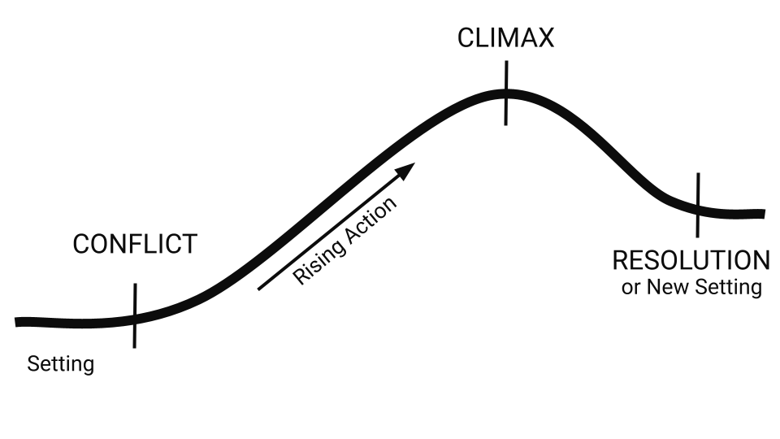

Figure 1.1: Plot arc

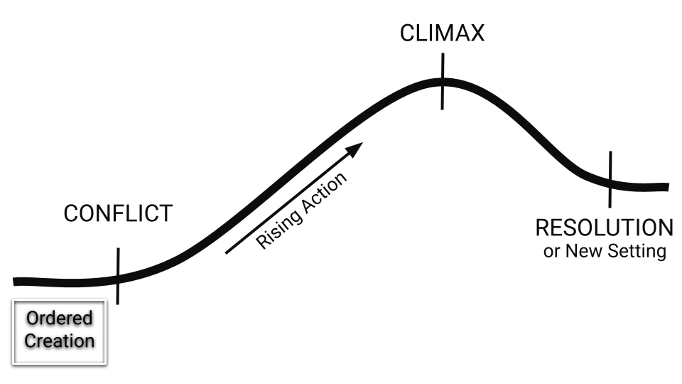
Figure 1.2: Plot arc - Genesis 1

Large Group Teaching

Lesson 1: What is the Bible?

A Wide Angle Perspective of the Bible

The Bible

Is a Theological History book…

Not a Self-Help Book

Not a Science Textbook

The Setting of the Bible - Creation

The Bible...

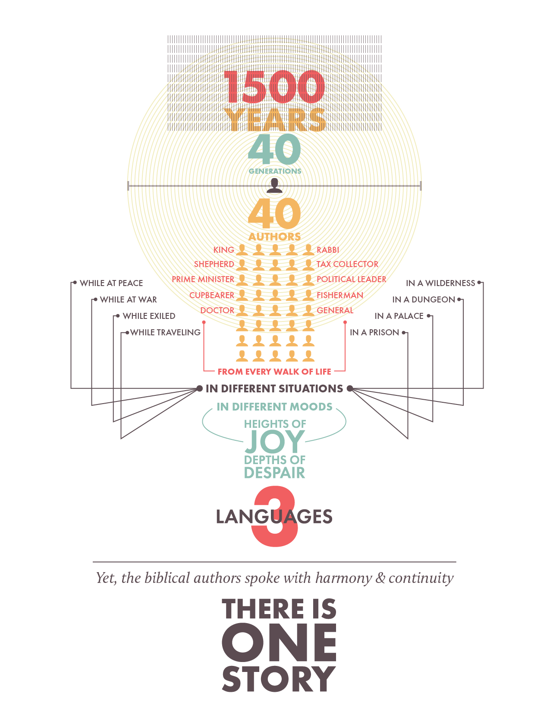
Figure 1.3: There is One Story

...is a theological history book which recounts the actions of God in the world.

...claims that God has acted in space, time and history to engage with his world and his people.

In the Bible, God has revealed His character and nature to people.

Through the Bible, God has told ONE story…

Over 1500 years

By 40 Authors

In 3 Languages

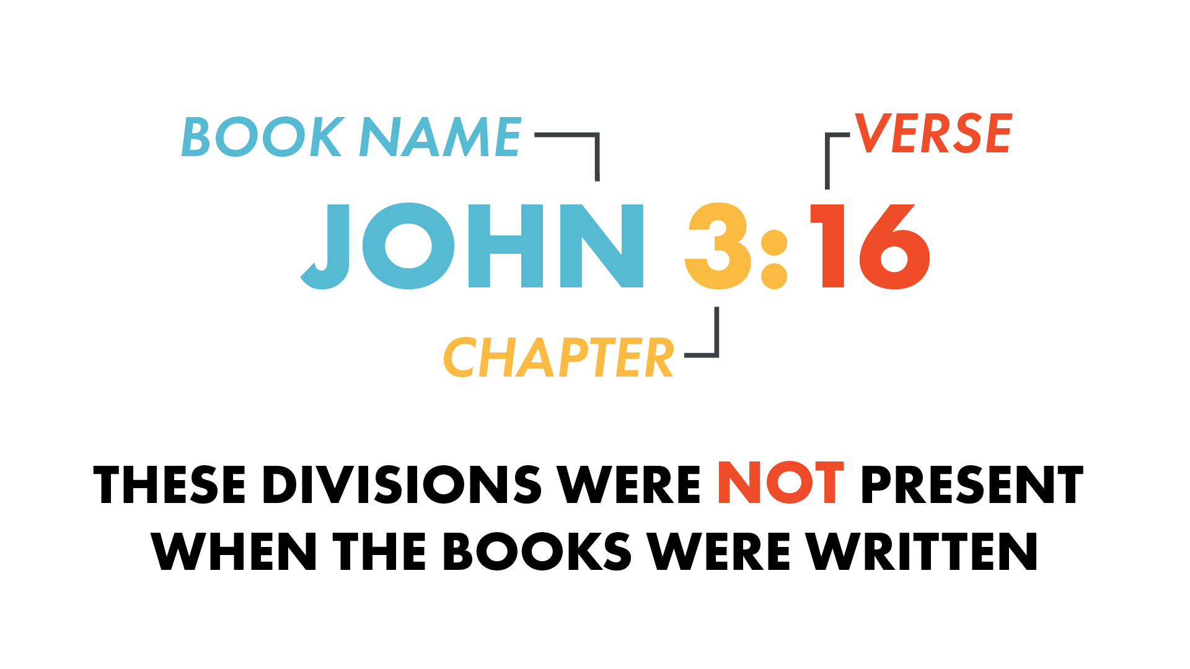
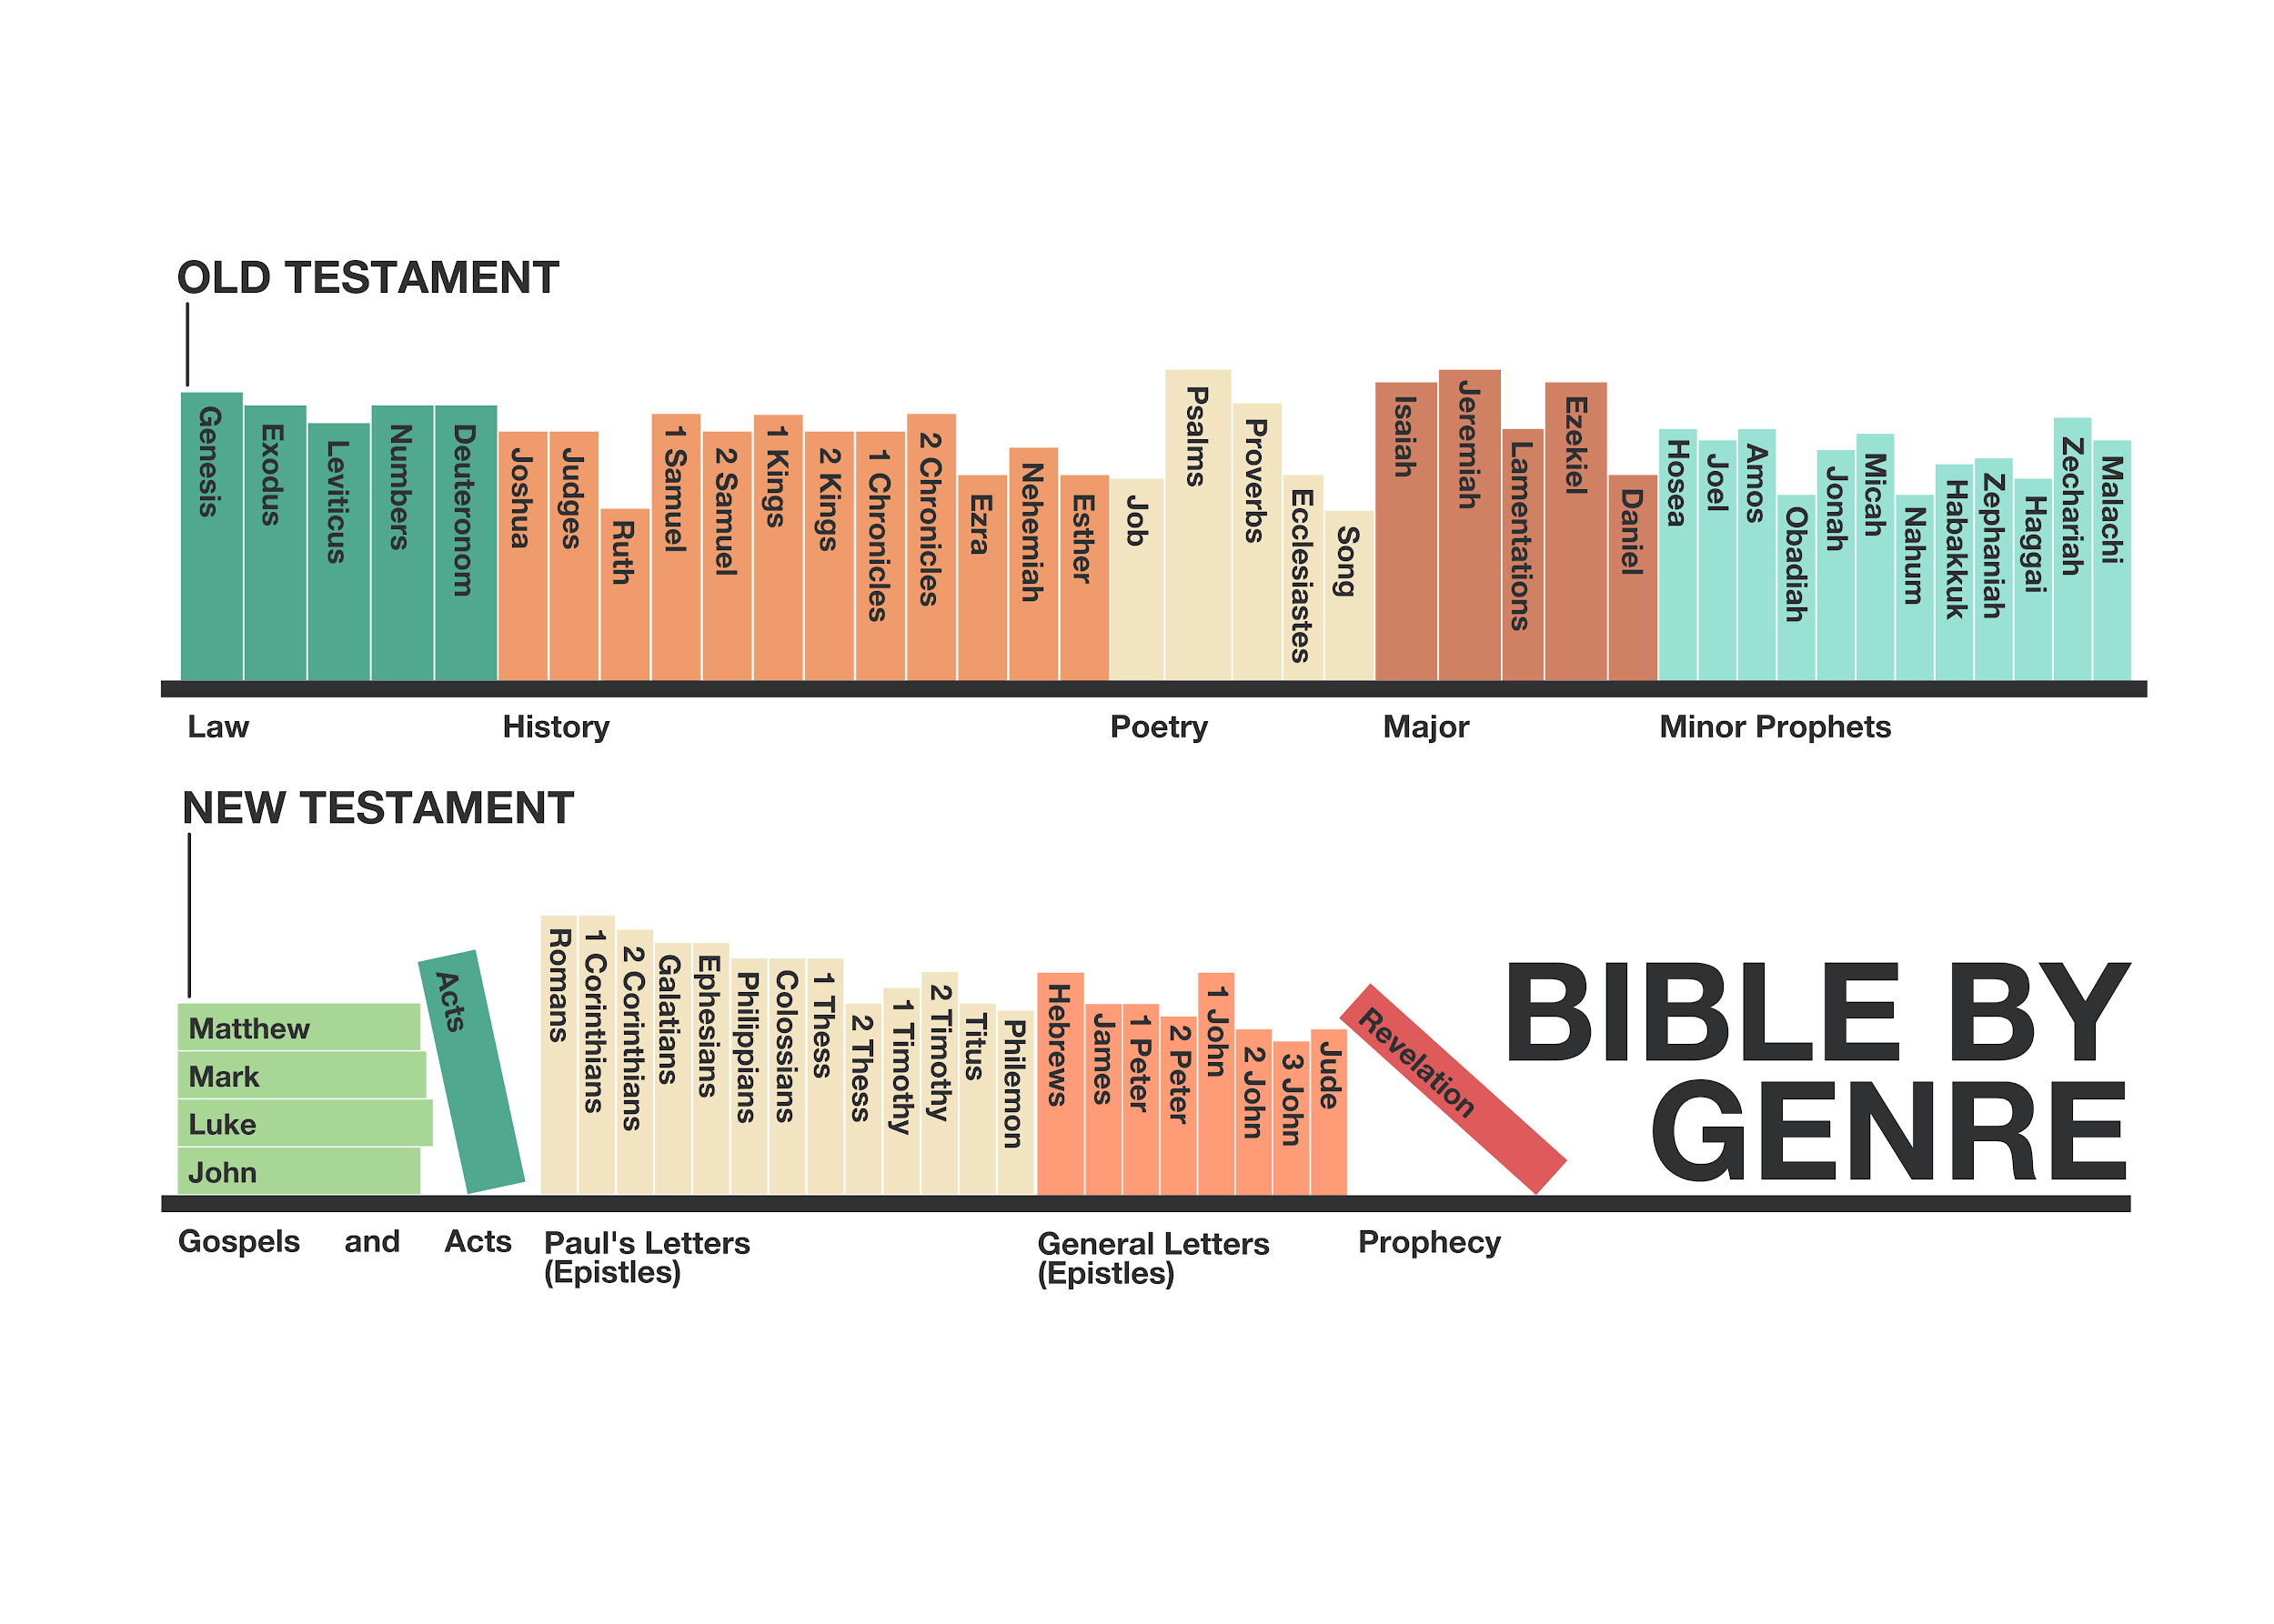
Figure 1:4: Bible by Genre

Figure 1.5: Book Divisions

The 66 books of the Bible are organized by their predominant genre (eg. law, history, poetry, prophetic writings, gospels, and letters).

Within individual books, there might be combination of different genres (eg. the Law books contain some history, the History books contain some law and some poetry etc).

Individual biblical books are organized with chapters (like any book!) and verses.

The Plot of the Bible
The Beginning & End of the Story

Read the following Scripture passages and answer the questions following each section.

1. The Characters in the Story
What does Genesis 2:4-25 teach us about people?

Genesis 1:26-28

²⁶ Then God said, “Let us make mankind in our image,in our likeness, so that they may rule over the fish in the sea and the birds in the sky, over the livestock and all the wild animals, and over all the creatures that move along the ground.”

²⁷ So God created mankind in his own image,

in the image of God he created them;

male and female he created them.

²⁸ God blessed them and said to them, “Be fruitful and increase in number; fill the earth and subdue it. Rule over the fish in the sea and the birds in the sky and over every living creature that moves on the ground.”

Genesis 2:4-25

⁴ This is the account of the heavens and the earth when they were created, when the Lord God made the earth and the heavens.

⁵ Now no shrub had yet appeared on the earth and no plant had yet sprung up, for the Lord God had not sent rain on the earth and there was no one to work the ground, ⁶ but streams came up from the earth and watered the whole surface of the ground. ⁷ Then the Lord God formed a man from the dust of the ground and breathed into his nostrils the breath of life, and the man became a living being.

⁸ Now the Lord God had planted a garden in the east, in Eden; and there he put the man he had formed. ⁹ The Lord God made all kinds of trees grow out of the ground—trees that were pleasing to the eye and good for food. In the middle of the garden were the tree of life and the tree of the knowledge of good and evil.

¹⁰ A river watering the garden flowed from Eden; from there it was separated into four headwaters. ¹¹ The name of the first is the Pishon; it winds through the entire land of Havilah, where there is gold. ¹² (The gold of that land is good; aromatic resin and onyx are also there.) ¹³ The name of the second river is the Gihon; it winds through the entire land of Cush.¹⁴ The name of the third river is the Tigris; it runs along the east side of Ashur. And the fourth river is the Euphrates.

¹⁵ The Lord God took the man and put him in the Garden of Eden to work it and take care of it. ¹⁶ And the Lord God commanded the man, “You are free to eat from any tree in the garden; ¹⁷ but you must not eat from the tree of the knowledge of good and evil, for when you eat from it you will certainly die.”

¹⁸ The Lord God said, “It is not good for the man to be alone. I will make a helper suitable for him.”

¹⁹ Now the Lord God had formed out of the ground all the wild animals and all the birds in the sky. He brought them to the man to see what he would name them; and whatever the man called each living creature, that was its name. ²⁰ So the man gave names to all the livestock, the birds in the sky and all the wild animals.

But for Adam no suitable helper was found. ²¹ So the Lord God caused the man to fall into a deep sleep; and while he was sleeping, he took one of the man’s ribs and then closed up the place with flesh. ²² Then the Lord God made a woman from the rib he had taken out of the man, and he brought her to the man.

²³ The man said,

“This is now bone of my bones

and flesh of my flesh;

she shall be called ‘woman,’

for she was taken out of man.”

²⁴ That is why a man leaves his father and mother and is united to his wife, and they become one flesh.

²⁵ Adam and his wife were both naked, and they felt no shame.
1. The Characters in the Story continued…
What does Genesis 2:4-25 teach us about people?
  - What were people created to do?
    - What work did God give to the man in Genesis 2?

    - What commands are given to both men and women in Genesis 1:28.

    - Why was the woman created according to Genesis 2?

  - What command governed their life in the garden?

  - How would you describe the relationship between the man and the woman in this text?

  - How would you describe the relationship between God and people in this text?

2. The Conflict of the Story
What does Genesis 3 teach us about what went wrong in creation?
Genesis 3

¹ Now the serpent was more crafty than any of the wild animals the Lord God had made. He said to the woman, “Did God really say, ‘You must not eat from any tree in the garden’?”

² The woman said to the serpent, “We may eat fruit from the trees in the garden, ³ but God did say, ‘You must not eat fruit from the tree that is in the middle of the garden, and you must not touch it, or you will die.’”

⁴ “You will not certainly die,” the serpent said to the woman. ⁵ “For God knows that when you eat from it your eyes will be opened, and you will be like God, knowing good and evil.”

⁶ When the woman saw that the fruit of the tree was good for food and pleasing to the eye, and also desirable for gaining wisdom, she took some and ate it. She also gave some to her husband, who was with her, and he ate it. ⁷ Then the eyes of both of them were opened, and they realized they were naked; so they sewed fig leaves together and made coverings for themselves.

⁸ Then the man and his wife heard the sound of the Lord God as he was walking in the garden in the cool of the day, and they hid from the Lord God among the trees of the garden. ⁹ But the Lord God called to the man, “Where are you?”

¹⁰ He answered, “I heard you in the garden, and I was afraid because I was naked; so I hid.”

¹¹ And he said, “Who told you that you were naked? Have you eaten from the tree that I commanded you not to eat from?”

¹² The man said, “The woman you put here with me—she gave me some fruit from the tree, and I ate it.” ¹³ Then the Lord God said to the woman, “What is this you have done?” The woman said, “The serpent deceived me, and I ate.”

¹⁴ So the Lord God said to the serpent, “Because you have done this,

“Cursed are you above all livestock

and all wild animals!

You will crawl on your belly

and you will eat dust

all the days of your life.

¹⁵ And I will put enmity

between you and the woman,

and between your offspring and hers;

he will crush your head,

and you will strike his heel.”

¹⁶ To the woman he said,

“I will make your pains in childbearing very severe;

with painful labor you will give birth to children.

Your desire will be for your husband,

and he will rule over you.”

¹⁷ To Adam he said, “Because you listened to your wife and ate fruit from the tree about which I commanded you, ‘You must not eat from it,’

“Cursed is the ground because of you;

through painful toil you will eat food from it

all the days of your life.

¹⁸ It will produce thorns and thistles for you,

and you will eat the plants of the field.

¹⁹ By the sweat of your brow

you will eat your food

until you return to the ground,

since from it you were taken;

for dust you are

and to dust you will return.”

²⁰ Adam named his wife Eve, because she would become the mother of all the living.

²¹ The Lord God made garments of skin for Adam and his wife and clothed them. ²² And the Lord God said, “The man has now become like one of us, knowing good and evil. He must not be allowed to reach out his hand and take also from the tree of life and eat, and live forever.” ²³ So the Lord God banished him from the Garden of Eden to work the ground from which he had been taken. ²⁴ After he drove the man out, he placed on the east side of the Garden of Eden cherubim and a flaming sword flashing back and forth to guard the way to the tree of life.

2. The Conflict of the Story continued...
What does Genesis 3 teach us about what went wrong in creation?
- Read the serpent’s questions and Eve’s responses in Genesis 3:1-6, and then review God’s command in Genesis 2:16-17.
  - What do you notice about the serpent’s question in Genesis 3:1, when you compare it with Genesis 2:16-17?

  - What do you notice about the woman’s reply in Genesis 3:2-3, when you compare it with Genesis 2:16-17?

  - As the conversation between the woman and the serpent progresses, what does the serpent cause the woman to doubt, or to question, about God’s character and His command?

    - How is this conversation instructive for all people today? What would Satan (the serpent) want us to think about God’s character and his trustworthiness?

  - According to this text, why does the woman listen to the serpent and take the fruit?

    - How is the woman’s response instructive for all people today? Why do people refuse to accept God’s commands and instead “take” things for themselves?

- According to Genesis 3:7-10, how did this act of disobedience (sin) by both the man and the woman affect their relationships?
  - How did it affect their relationship with each other?

  - How did it affect their relationship with God?

- What are the consequences of their disobedience (sin)?
  - For the woman - Review Genesis 3:16 in light of Genesis 1:28 and Genesis 2:18-25.
    - According to Genesis 2:18-25, what was the woman supposed to do and be?

    - How is the woman’s original role / responsibility frustrated or damaged in Genesis 3:16 as a consequence of her disobedience (sin)?

  - For the man - Review Genesis 3:17-19 in light of Genesis 1:28 and Genesis 2:15.
    - According to Genesis 2:15, what was the man supposed to do?

    - How is the man’s original role / responsibility frustrated or damaged in Genesis 3:17-19 as a consequence of his disobedience (sin)?

- List the variety of ways that God responds to their disobedience (sin).
  - Genesis 3:9, 11, 13 - How does God engage with people in these verses? Why?

  - Genesis 3:21-24 - How does God engage with people in these verses? Why?

  - Is there any hope of restoration between people and God in this chapter?

- How does God describe the future dynamic between people and the serpent in 3:14-15?

  - What will be the final fate of the serpent? What does this mean?

- How does reading and understanding Genesis 3 help us to understand our world today?

Large Group Teaching

Lesson 2: The Plot of the Bible

The Beginning and the End of the Story

The Characters and Conflict - Genesis 2-3

The Resolution - Revelation 20:10, Revelation 21:1-5, Revelation 22:1-15

Revelation 20:10

¹⁰And the devil, who deceived them, was thrown into the lake of burning sulfur, where the beast and the false prophet had been thrown. They will be tormented day and night for ever and ever.

Revelation 21:1-5

¹ Then I saw “a new heaven and a new earth,” for the first heaven and the first earth had passed away, and there was no longer any sea. ² I saw the Holy City, the new Jerusalem, coming down out of heaven from God, prepared as a bride beautifully dressed for her husband. ³ And I heard a loud voice from the throne saying, “Look! God’s dwelling place is now among the people, and he will dwell with them. They will be his people, and God himself will be with them and be their God. ⁴ ‘He will wipe every tear from their eyes. There will be no more death’ or mourning or crying or pain, for the old order of things has passed away.”

⁵ He who was seated on the throne said, “I am making everything new!” Then he said, “Write this down, for these words are trustworthy and true.”

Revelation 22:1-5

¹ Then the angel showed me the river of the water of life, as clear as crystal, flowing from the throne of God and of the Lamb ² down the middle of the great street of the city. On each side of the river stood the tree of life, bearing twelve crops of fruit, yielding its fruit every month. And the leaves of the tree are for the healing of the nations. ³ No longer will there be any curse. The throne of God and of the Lamb will be in the city, and his servants will serve him. ⁴ They will see his face, and his name will be on their foreheads. ⁵ There will be no more night. They will not need the light of a lamp or the light of the sun, for the Lord God will give them light. And they will reign for ever and ever.

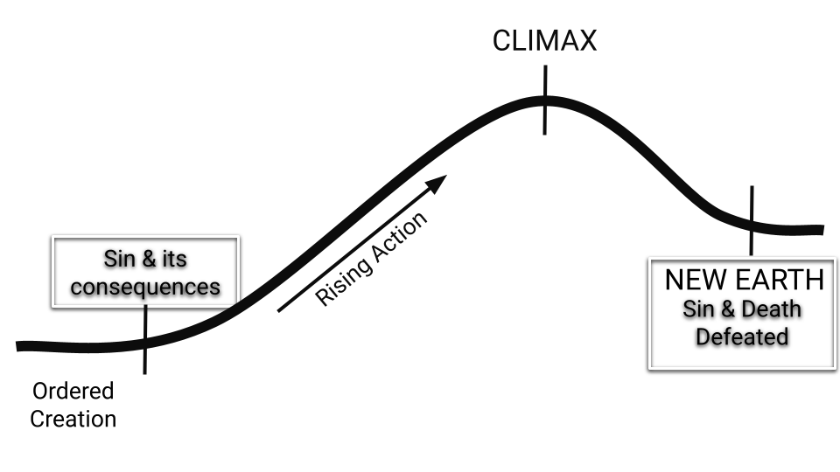
Figure 2.1: Plot arc - Genesis 2-3, Revelation 21-22

The Heart of People
God’s Diagnosis and Initial Response

At the end of Genesis 3, people were banished from the Garden of Eden and from the tree of life, but God continued to sustain life on earth and engage with people personally. Adam and Eve had children, and when their son Cain was tempted to sin, God warned him against it but Cain refused to listen (Genesis 4:6-8) . In the list of Adam and Eve’s descendants which follows in Genesis 5, only one man, Enoch, is known for walking with God (Genesis 5:22-24). In this week’s lesson, we’re going to investigate God’s diagnosis of the condition of the human heart and his initial response to this diagnosis.

Read the Bible passages below and answer the questions that follow.

1. God’s Diagnosis

Genesis 6:1-12
¹ When human beings began to increase in number on the earth and daughters were born to them, ² the sons of God saw that the daughters of humans were beautiful, and they married any of them they chose. ³ Then the Lord said, “My Spirit will not contend with humans forever, for they are mortal; their days will be a hundred and twenty years.” ⁴ The Nephilim were on the earth in those days—and also afterward—when the sons of God went to the daughters of humans and had children by them. They were the heroes of old, men of renown.
⁵ The Lord saw how great the wickedness of the human race had become on the earth, and that every inclination of the thoughts of the human heart was only evil all the time. ⁶ The Lord regretted that he had made human beings on the earth, and his heart was deeply troubled. ⁷ So the Lord said, “I will wipe from the face of the earth the human race I have created—and with them the animals, the birds and the creatures that move along the ground—for I regret that I have made them.” ⁸ But Noah found favor in the eyes of the Lord.
⁹ This is the account of Noah and his family.Noah was a righteous man, blameless among the people of his time, and he walked faithfully with God. ¹⁰ Noah had three sons: Shem, Ham and Japheth. ¹¹ Now the earth was corrupt in God’s sight and was full of violence. ¹² God saw how corrupt the earth had become, for all the people on earth had corrupted their ways.

1. God’s Diagnosis continued...

  - In the genealogy which we didn't read (Genesis 5), it is recorded that people lived between 777 - 969 years! Why did God reduce the lifespan of people, according to this text?

  - What is God’s diagnosis of the human race and the condition of the human heart?

    - Do you think God’s diagnosis in this text was specific to people in the ancient world during the time of Noah, or is it a diagnosis which applies to people at all times in all cultures?

    - What is your initial response to this diagnosis? Do you think it's true? Do you have any questions about it?

    - Do you think people in our western twenty-first century culture would agree with this diagnosis?

  - What does this passage teach us about the nature of sin and how God responds to sin?

    - 6:5 - sin’s origin

    - 6:6 - sin’s effect on God

    - 6:7 - Gods’ response to sin

    - 6:11 - sin’s effect on the earth

    - 6:12 - sin’s effect on people

      - How would you summarize what Genesis 6 teaches on the nature and consequences of sin?

2. God’s Initial Response

Genesis 6:13-8:22

¹³ So God said to Noah, “I am going to put an end to all people, for the earth is filled with violence because of them. I am surely going to destroy both them and the earth. ¹⁴ So make yourself an ark of cypress wood; make rooms in it and coat it with pitch inside and out. ¹⁵ This is how you are to build it: The ark is to be three hundred cubits long, fifty cubits wide and thirty cubits high. ¹⁶ Make a roof for it, leaving below the roof an opening one cubit high all around.Put a door in the side of the ark and make lower, middle and upper decks. ¹⁷ I am going to bring floodwaters on the earth to destroy all life under the heavens, every creature that has the breath of life in it. Everything on earth will perish. ¹⁸ But I will establish my covenant with you, and you will enter the ark—you and your sons and your wife and your sons’ wives with you. ¹⁹ You are to bring into the ark two of all living creatures, male and female, to keep them alive with you. ²⁰ Two of every kind of bird, of every kind of animal and of every kind of creature that moves along the ground will come to you to be kept alive. ²¹ You are to take every kind of food that is to be eaten and store it away as food for you and for them.”

²² Noah did everything just as God commanded him.
Genesis 7

¹ The Lord then said to Noah, “Go into the ark, you and your whole family, because I have found you righteous in this generation. ² Take with you seven pairs of every kind of clean animal, a male and its mate, and one pair of every kind of unclean animal, a male and its mate, ³ and also seven pairs of every kind of bird, male and female, to keep their various kinds alive throughout the earth. ⁴ Seven days from now I will send rain on the earth for forty days and forty nights, and I will wipe from the face of the earth every living creature I have made.”

⁵ And Noah did all that the Lord commanded him.

⁶ Noah was six hundred years old when the floodwaters came on the earth. ⁷ And Noah and his sons and his wife and his sons’ wives entered the ark to escape the waters of the flood. ⁸ Pairs of clean and unclean animals, of birds and of all creatures that move along the ground, ⁹ male and female, came to Noah and entered the ark, as God had commanded Noah. ¹⁰ And after the seven days the floodwaters came on the earth.

¹¹ In the six hundredth year of Noah’s life, on the seventeenth day of the second month—on that day all the springs of the great deep burst forth, and the floodgates of the heavens were opened. ¹² And rain fell on the earth forty days and forty nights.

¹³ On that very day Noah and his sons, Shem, Ham and Japheth, together with his wife and the wives of his three sons, entered the ark. ¹⁴ They had with them every wild animal according to its kind, all livestock according to their kinds, every creature that moves along the ground according to its kind and every bird according to its kind, everything with wings. ¹⁵ Pairs of all creatures that have the breath of life in them came to Noah and entered the ark. ¹⁶ The animals going in were male and female of every living thing, as God had commanded Noah. Then the Lord shut him in.

¹⁷ For forty days the flood kept coming on the earth, and as the waters increased they lifted the ark high above the earth. ¹⁸ The waters rose and increased greatly on the earth, and the ark floated on the surface of the water. ¹⁹ They rose greatly on the earth, and all the high mountains under the entire heavens were covered. ²⁰ The waters rose and covered the mountains to a depth of more than fifteen cubits. ²¹ Every living thing that moved on land perished—birds, livestock, wild animals, all the creatures that swarm over the earth, and all mankind. ²² Everything on dry land that had the breath of life in its nostrils died. ²³ Every living thing on the face of the earth was wiped out; people and animals and the creatures that move along the ground and the birds were wiped from the earth. Only Noah was left, and those with him in the ark.

²⁴ The waters flooded the earth for a hundred and fifty days.
Genesis 8

¹ But God remembered Noah and all the wild animals and the livestock that were with him in the ark, and he sent a wind over the earth, and the waters receded. ² Now the springs of the deep and the floodgates of the heavens had been closed, and the rain had stopped falling from the sky. ³ The water receded steadily from the earth. At the end of the hundred and fifty days the water had gone down, ⁴ and on the seventeenth day of the seventh month the ark came to rest on the mountains of Ararat. ⁵ The waters continued to recede until the tenth month, and on the first day of the tenth month the tops of the mountains became visible.

⁶ After forty days Noah opened a window he had made in the ark ⁷ and sent out a raven, and it kept flying back and forth until the water had dried up from the earth. ⁸ Then he sent out a dove to see if the water had receded from the surface of the ground. ⁹ But the dove could find nowhere to perch because there was water over all the surface of the earth; so it returned to Noah in the ark. He reached out his hand and took the dove and brought it back to himself in the ark. ¹⁰ He waited seven more days and again sent out the dove from the ark. ¹¹ When the dove returned to him in the evening, there in its beak was a freshly plucked olive leaf! Then Noah knew that the water had receded from the earth. ¹² He waited seven more days and sent the dove out again, but this time it did not return to him.

¹³ By the first day of the first month of Noah’s six hundred and first year, the water had dried up from the earth. Noah then removed the covering from the ark and saw that the surface of the ground was dry. ¹⁴ By the twenty-seventh day of the second month the earth was completely dry.

¹⁵ Then God said to Noah, ¹⁶ “Come out of the ark, you and your wife and your sons and their wives. ¹⁷ Bring out every kind of living creature that is with you—the birds, the animals, and all the creatures that move along the ground—so they can multiply on the earth and be fruitful and increase in number on it.”

¹⁸ So Noah came out, together with his sons and his wife and his sons’ wives. ¹⁹ All the animals and all the creatures that move along the ground and all the birds—everything that moves on land—came out of the ark, one kind after another.

²⁰ Then Noah built an altar to the Lord and, taking some of all the clean animals and clean birds, he sacrificed burnt offerings on it. ²¹ The Lord smelled the pleasing aroma and said in his heart: “Never again will I curse the ground because of humans, even though every inclination of the human heart is evil from childhood. And never again will I destroy all living creatures, as I have done.

²² “As long as the earth endures,

seedtime and harvest,

cold and heat,

summer and winter,

day and night

will never cease.”

2. God’s Initial Response continued...
- The Plan
  - What was God’s role in the rescue of Noah and his family?

  - What was Noah’s role in his own rescue? What did he do and why did he do it? (check out Hebrews 11:7 if you want as well).

    - How are the roles of God and Noah in this situation instructive for us today, as we think about how we are saved from the consequences of sin?

- The “Success” of the Plan
  - According to Genesis 6:13, what was God’s plan in sending a flood?

  - According to Genesis 7:21-23, how “successful” was God’s plan?

  - According to Genesis 8:21-22, how “successful” was God’s plan? (compare this text with what we read earlier in Genesis 6:5).

    - Did the flood “solve” the problem of the human heart?

Large Group Teaching

Lesson 3: The Heart of People
God’s Diagnosis and Long Term Response

God’s Diagnosis of the Human Heart - Genesis 6:5, 8:21-22

God’s Long Term Response - Genesis 9:1-17; Genesis 9:18-27

Genesis 9

¹ Then God blessed Noah and his sons, saying to them, “Be fruitful and increase in number and fill the earth. ² The fear and dread of you will fall on all the beasts of the earth, and on all the birds in the sky, on every creature that moves along the ground, and on all the fish in the sea; they are given into your hands. ³ Everything that lives and moves about will be food for you. Just as I gave you the green plants, I now give you everything.

⁴ “But you must not eat meat that has its lifeblood still in it. ⁵ And for your lifeblood I will surely demand an accounting. I will demand an accounting from every animal. And from each human being, too, I will demand an accounting for the life of another human being.

⁶ “Whoever sheds human blood,

by humans shall their blood be shed;

for in the image of God

has God made mankind.

⁷ As for you, be fruitful and increase in number; multiply on the earth and increase upon it.”

⁸ Then God said to Noah and to his sons with him: ⁹ “I now establish my covenant with you and with your descendants after you ¹⁰ and with every living creature that was with you—the birds, the livestock and all the wild animals, all those that came out of the ark with you—every living creature on earth. ¹¹ I establish my covenant with you: Never again will all life be destroyed by the waters of a flood; never again will there be a flood to destroy the earth.”

¹² And God said, “This is the sign of the covenant I am making between me and you and every living creature with you, a covenant for all generations to come: ¹³ I have set my rainbow in the clouds, and it will be the sign of the covenant between me and the earth. ¹⁴ Whenever I bring clouds over the earth and the rainbow appears in the clouds, ¹⁵ I will remember my covenant between me and you and all living creatures of every kind. Never again will the waters become a flood to destroy all life. ¹⁶ Whenever the rainbow appears in the clouds, I will see it and remember the everlasting covenant between God and all living creatures of every kind on the earth.”

¹⁷ So God said to Noah, “This is the sign of the covenant I have established between me and all life on the earth.”

¹⁸ The sons of Noah who came out of the ark were Shem, Ham and Japheth. (Ham was the father of Canaan.) ¹⁹ These were the three sons of Noah, and from them came the people who were scattered over the whole earth.

²⁰ Noah, a man of the soil, proceeded to plant a vineyard. ²¹ When he drank some of its wine, he became drunk and lay uncovered inside his tent. ²² Ham, the father of Canaan, saw his father naked and told his two brothers outside. ²³ But Shem and Japheth took a garment and laid it across their shoulders; then they walked in backward and covered their father’s naked body. Their faces were turned the other way so that they would not see their father naked.

²⁴ When Noah awoke from his wine and found out what his youngest son had done to him, ²⁵ he said,

“Cursed be Canaan!

The lowest of slaves

will he be to his brothers.”

²⁶ He also said,

“Praise be to the Lord, the God of Shem!

May Canaan be the slave of Shem.

²⁷ May God extend Japheth’s territory;

may Japheth live in the tents of Shem,

and may Canaan be the slave of Japheth.”

²⁸ After the flood Noah lived 350 years. ²⁹ Noah lived a total of 950 years, and then he died.

THE STORY BETWEEN THE PROMISES
NUMBER ONE

After the flood, people continued to be fruitful and multiply and Genesis 10 provides a list of Noah’s descendants. However, people did not want to fill the earth as God commanded in Genesis 1:28 and instead, they joined together to build a city and a tower in rebellion to His wishes (Genesis 11:4). In response, God gave them different languages so that they scattered “over the face of the whole earth” (Genesis 11:9).

As the biblical story continues to unfold it becomes evident that, unless God intervenes, human history will simply go from bad to worse. Something must be done to solve the problem of the human heart. Something must be done to deal with the problem of sin.

So God sets His plan of redemption in motion. This plan begins with Him making a series of promises to a man named Abram which are repeated to his son, Isaac, and to his grandson, Jacob. These promises form the framework for all of God’s future work in the world. Since the promises to Abraham and his family move the entire biblical narrative forward, it’s important that we understand them. These promises are the focus of Lesson 4.

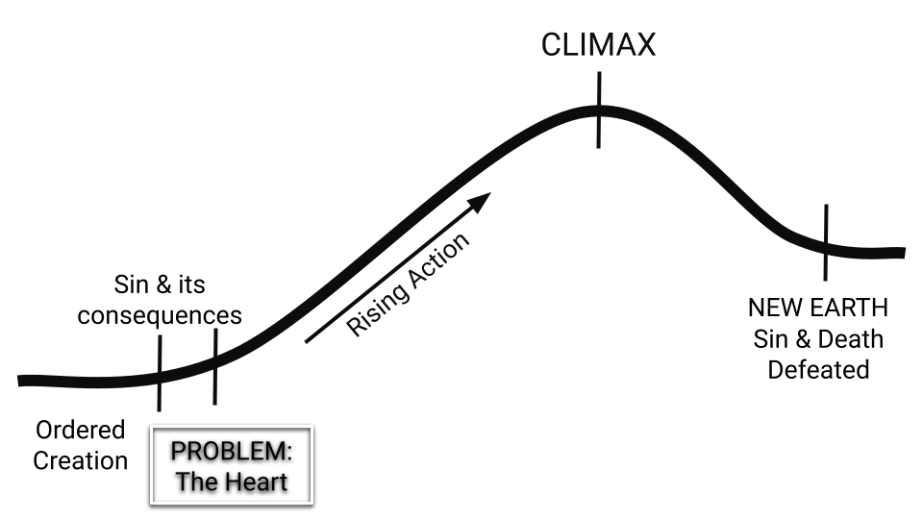
Figure 3.1: Plot arc - Genesis 6-9

The Solution of God - Promises to Abram

Read the Bible passages below and answer the questions that follow.

Genesis 12 - God’s Promises First Spoken

¹ The Lord had said to Abram, “Go from your country, your people and your father’s household to the land I will show you.

² “I will make you into a great nation,

and I will bless you;

I will make your name great,

and you will be a blessing.

³ I will bless those who bless you,

and whoever curses you I will curse;

and all peoples on earth

will be blessed through you.”

⁴ So Abram went, as the Lord had told him; and Lot went with him. Abram was seventy-five years old when he set out from Harran. ⁵ He took his wife Sarai, his nephew Lot, all the possessions they had accumulated and the people they had acquired in Harran, and they set out for the land of Canaan, and they arrived there.

⁶ Abram traveled through the land as far as the site of the great tree of Moreh at Shechem. At that time the Canaanites were in the land. ⁷ The Lord appeared to Abram and said, “To your offspring I will give this land.” So he built an altar there to the Lord, who had appeared to him.

⁸ From there he went on toward the hills east of Bethel and pitched his tent, with Bethel on the west and Ai on the east. There he built an altar to the Lord and called on the name of the Lord.

⁹ Then Abram set out and continued toward the Negev.

¹⁰ Now there was a famine in the land, and Abram went down to Egypt to live there for a while because the famine was severe. ¹¹ As he was about to enter Egypt, he said to his wife Sarai, “I know what a beautiful woman you are. ¹² When the Egyptians see you, they will say, ‘This is his wife.’ Then they will kill me but will let you live. ¹³ Say you are my sister, so that I will be treated well for your sake and my life will be spared because of you.”

¹⁴ When Abram came to Egypt, the Egyptians saw that Sarai was a very beautiful woman. ¹⁵ And when Pharaoh’s officials saw her, they praised her to Pharaoh, and she was taken into his palace. ¹⁶ He treated Abram well for her sake, and Abram acquired sheep and cattle, male and female donkeys, male and female servants, and camels.

¹⁷ But the Lord inflicted serious diseases on Pharaoh and his household because of Abram’s wife Sarai. ¹⁸ So Pharaoh summoned Abram. “What have you done to me?” he said. “Why didn’t you tell me she was your wife? ¹⁹ Why did you say, ‘She is my sister,’ so that I took her to be my wife? Now then, here is your wife. Take her and go!” 2⁰ Then Pharaoh gave orders about Abram to his men, and they sent him on his way, with his wife and everything he had.

Genesis 17:1-8 - God’s Promises Spoken Again

¹ When Abram was ninety-nine years old, the Lord appeared to him and said, “I am God Almighty; walk before me faithfully and be blameless. ² Then I will make my covenant between me and you and will greatly increase your numbers.”

³ Abram fell facedown, and God said to him, ⁴ “As for me, this is my covenant with you: You will be the father of many nations. ⁵ No longer will you be called Abram; your name will be Abraham, for I have made you a father of many nations. ⁶ I will make you very fruitful; I will make nations of you, and kings will come from you. ⁷ I will establish my covenant as an everlasting covenant between me and you and your descendants after you for the generations to come, to be your God and the God of your descendants after you. ⁸ The whole land of Canaan, where you now reside as a foreigner, I will give as an everlasting possession to you and your descendants after you; and I will be their God.”

Genesis 26:1-5 - God Repeats the Promises to Abraham’s son Isaac

¹ Now there was a famine in the land—besides the previous famine in Abraham’s time—and Isaac went to Abimelek king of the Philistines in Gerar. ² The Lord appeared to Isaac and said, “Do not go down to Egypt; live in the land where I tell you to live. ³ Stay in this land for a while, and I will be with you and will bless you. For to you and your descendants I will give all these lands and will confirm the oath I swore to your father Abraham. ⁴ I will make your descendants as numerous as the stars in the sky and will give them all these lands, and through your offspring all nations on earth will be blessed,⁵ because Abraham obeyed me and did everything I required of him, keeping my commands, my decrees and my instructions.”

Genesis 28:10-15 - God Repeats the Promises to Abraham’s grandson Jacob

¹⁰ Jacob left Beersheba and set out for Harran. ¹¹ When he reached a certain place, he stopped for the night because the sun had set. Taking one of the stones there, he put it under his head and lay down to sleep. ¹² He had a dream in which he saw a stairway resting on the earth, with its top reaching to heaven, and the angels of God were ascending and descending on it.

¹³ There above it stood the Lord, and he said: “I am the Lord, the God of your father Abraham and the God of Isaac. I will give you and your descendants the land on which you are lying. ¹⁴ Your descendants will be like the dust of the earth, and you will spread out to the west and to the east, to the north and to the south. All peoples on earth will be blessed through you and your offspring. ¹⁵ I am with you and will watch over you wherever you go, and I will bring you back to this land. I will not leave you until I have done what I have promised you.”

1. Promises to Abram and his Family

  - The promises to Abram can be categorized into four main ideas. Under each section below, note the specifics of the promise and then summarize the category.
    - Genesis 12:2a, 17:2-6, 26:4a, 28:14a

    - Genesis 12:2b-3a, 17:7, 28:15

    - Genesis 12:3b, 26:4b, 28:14b

    - Genesis 12:6-7, 17;8, 26:3, 28:13,

  - What do you think is the significance of God beginning His plan for Abraham (note that Abram’s name was changed in 17:5) and his descendants with promises?
    - Did anything prompt the promises of Genesis 12:1-3 or did God initiate towards Abram entirely on His own volition? (see Joshua 24:2-3 for more background on who Abram was prior to God’s promises)

    - Under what circumstances will the promises of Genesis 12:1-3 be fulfilled? Are there any conditions attached to these original promises?

  - As you read Genesis 12 and Genesis 17, you’ll notice that they both mention Abram’s age. God promises Abram offspring in Genesis 12, but Isaac (his promised son) is not born until Genesis 21:1-5.

    - How many years pass between the promise and its fulfillment?

    - What does this teach us about God?

    - How does this knowledge about God encourage or challenge you today?

Abram’s Response

  - How did Abram respond to God’s promises in Genesis 12:1-9?
    - What did he do in response? (Genesis 12:4-9)

    - What do his actions teach us about what it looks like to respond to God in faith?

  - In the midst of this great story of God’s promises and Abram’s obedience, we also get further insight into Abram’s character in Genesis 12:10-20.
    - What happens in these verses?

    - Why do you think the biblical authors included this story, which shows a more questionable side of Abram’s character?

    - How does this part of the story challenge or encourage you today?

Large Group Teaching

Lesson 4: The Solution of God - Promises to Abram/Abraham

Covenants - Genesis 15, 17:9-14

Genesis 15

¹ After this, the word of the Lord came to Abram in a vision:

“Do not be afraid, Abram.

I am your shield,

your very great reward.”

² But Abram said, “Sovereign Lord, what can you give me since I remain childless and the one who will inherit my estate is Eliezer of Damascus?” ³ And Abram said, “You have given me no children; so a servant in my household will be my heir.”

⁴ Then the word of the Lord came to him: “This man will not be your heir, but a son who is your own flesh and blood will be your heir.” ⁵ He took him outside and said, “Look up at the sky and count the stars—if indeed you can count them.” Then he said to him, “So shall your offspring be.”

⁶ Abram believed the Lord, and he credited it to him as righteousness. ⁷ He also said to him, “I am the Lord, who brought you out of Ur of the Chaldeans to give you this land to take possession of it.”

⁸ But Abram said, “Sovereign Lord, how can I know that I will gain possession of it?”

⁹ So the Lord said to him, “Bring me a heifer, a goat and a ram, each three years old, along with a dove and a young pigeon.”

¹⁰ Abram brought all these to him, cut them in two and arranged the halves opposite each other; the birds, however, he did not cut in half. ¹¹ Then birds of prey came down on the carcasses, but Abram drove them away.

¹² As the sun was setting, Abram fell into a deep sleep, and a thick and dreadful darkness came over him. ¹³ Then the Lord said to him, “Know for certain that for four hundred years your descendants will be strangers in a country not their own and that they will be enslaved and mistreated there. ¹⁴ But I will punish the nation they serve as slaves, and afterward they will come out with great possessions. ¹⁵ You, however, will go to your ancestors in peace and be buried at a good old age. ¹⁶ In the fourth generation your descendants will come back here, for the sin of the Amorites has not yet reached its full measure.”

¹⁷ When the sun had set and darkness had fallen, a smoking firepot with a blazing torch appeared and passed between the pieces. ¹⁸ On that day the Lord made a covenant with Abram and said, “To your descendants I give this land, from the Wadi of Egypt to the great river, the Euphrates— ¹⁹ the land of the Kenites, Kenizzites, Kadmonites, ²⁰ Hittites, Perizzites, Rephaites, ²¹ Amorites, Canaanites, Girgashites and Jebusites.”

Genesis 17:9-14

⁹ Then God said to Abraham, “As for you, you must keep my covenant, you and your descendants after you for the generations to come. ¹⁰ This is my covenant with you and your descendants after you, the covenant you are to keep: Every male among you shall be circumcised. ¹¹ You are to undergo circumcision, and it will be the sign of the covenant between me and you.

¹² For the generations to come every male among you who is eight days old must be circumcised, including those born in your household or bought with money from a foreigner—those who are not your offspring. ¹³ Whether born in your household or bought with your money, they must be circumcised. My covenant in your flesh is to be an everlasting covenant. ¹⁴ Any uncircumcised male, who has not been circumcised in the flesh, will be cut off from his people; he has broken my covenant.”

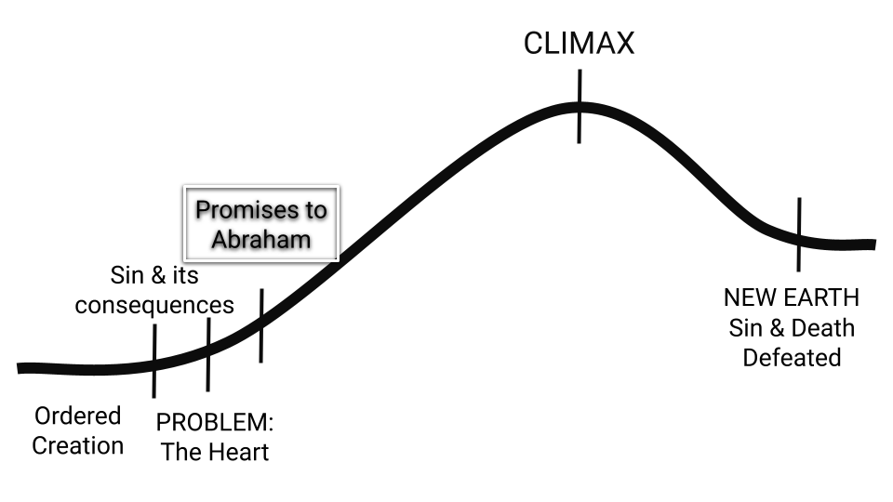
Figure 4.1: Plot arc - Genesis 12-50

THE STORY BETWEEN THE PROMISES
NUMBER TWO

Life in Canaan
God promised Abraham descendants as numerous as the stars (Genesis 15:5), and yet Abraham died with very few children, and only one (Isaac) who was the official ‘heir’ of the promise.

Isaac married Rebekah and had two sons named Jacob and Esau (Genesis 25). Jacob, who became the heir through deceit and trickery, ended up with two wives and two concubines who provided the family with twelve sons (Genesis 29:31-30:24, 35:16-18). During an encounter with God later in his life Jacob is renamed “Israel” (Genesis 32:22-30), and his twelve sons become known as the leaders of the twelve tribes of Israel.

Jacob had a favourite son named Joseph, to whom he gave a “coat of many colors” (Genesis 37). Jacob’s favouritism was not well received by Joseph’s brothers, who took advantage of a moment when Joseph was unprotected and sold him to slave traders who brought him into Egypt (Genesis 37:12-36). But while he was in Egypt, God was with him and Joseph eventually rose to the position of being second in command to Pharaoh, the king of Egypt.

Life in Egypt
Later, when Jacobs’s family experienced a famine in Canaan, Jacob’s sons travelled to Egypt for food and were reunited with Joseph. Eventually, the entire family relocated to Egypt. This is where the book of Genesis ends.

The family lived in Egypt for 400 years and grew in number. During those years, God was fulfilling one of the promises to Abraham: making him into a great nation! Over time the descendants of Jacob (who were called the Israelites or the Hebrews) were seen as a threat to those in power in Egypt and so they were enslaved and treated harshly (Exodus 1-2).

Because God was aware of His people’s suffering (Exodus 2:23-25), and was faithful to His promises to Abraham (Genesis 15:12-15), He designated a man named Moses to confront the current Pharaoh and lead the Israelite people to freedom.

Through this confrontation God brought punishment upon Egypt through a series of plagues. During the final plague, God instructed the Israelites to kill a perfect lamb (with no defects) and to paint the blood of the lamb on the doorposts of their houses. Everyone who obeyed these commands was spared from death; the angel of death killed the firstborn son of those who did not paint their doorposts with blood and he “passed over” the homes which did. God commanded the Israelites to commemorate this event by creating an annual festival called “Passover”.

After this plague, Pharaoh commanded the Israelites to leave, but later he regretted his decision and chased after them. God miraculously provided them with a pathway through the Red Sea (Exodus 14-15) to deliver them from their enemies. We will pick up the story as the Israelites begin their journey back towards the land that God promised to Abraham.

See map on next page.

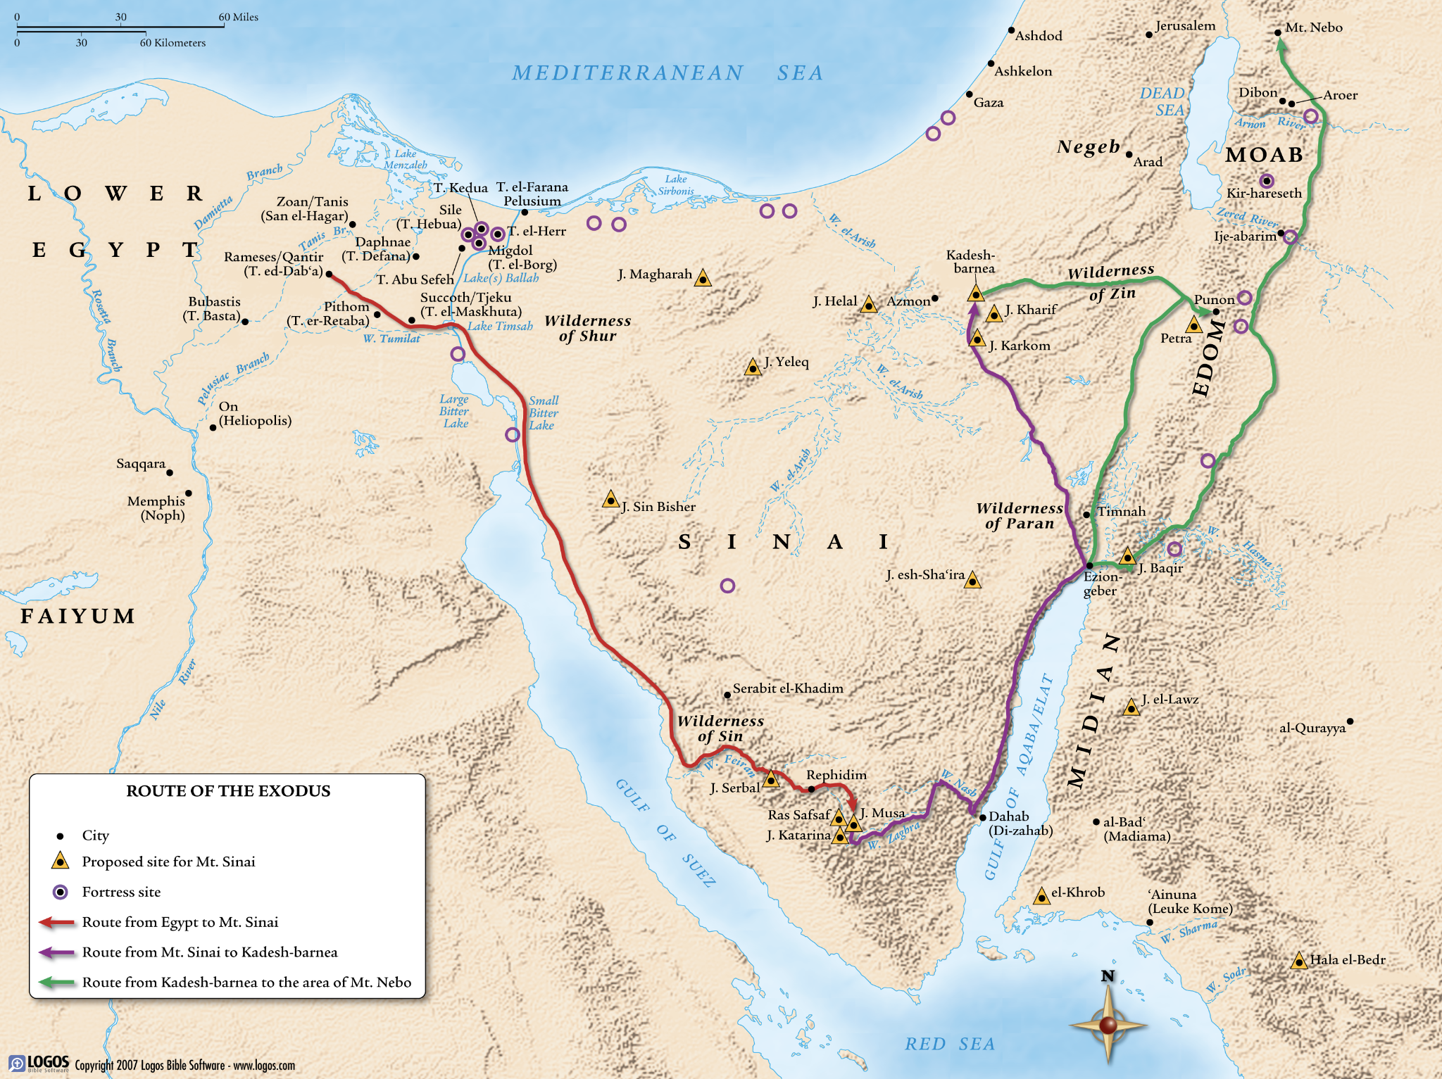
Figure 4.2: Plot arc - Route of the Exodus

The Solution of God - Promises to Moses (Part 1)

Read the Bible passages below and answer the questions that follow.

1. God’s Promises

Exodus 19

¹ On the first day of the third month after the Israelites left Egypt—on that very day—they came to the Desert of Sinai. ² After they set out from Rephidim, they entered the Desert of Sinai, and Israel camped there in the desert in front of the mountain.

³ Then Moses went up to God, and the Lord called to him from the mountain and said, “This is what you are to say to the descendants of Jacob and what you are to tell the people of Israel: ⁴ ‘You yourselves have seen what I did to Egypt, and how I carried you on eagles’ wings and brought you to myself. ⁵ Now if you obey me fully and keep my covenant, then out of all nations you will be my treasured possession. Although the whole earth is mine, ⁶ you will be for me a kingdom of priests and a holy nation.’ These are the words you are to speak to the Israelites.”

1. God’s Promises continued…

- According to the “Story between the Promises - #2” on pages 47-48, how did God deliver Israel from Egypt? (eg. what means or methods did He use?)

  - Now in Exodus 19:4, how does God describe this deliverance? What is God’s role in the rescue of Israel?

  - What is Israel’s role in their own rescue?

    - How are the roles of God and the Israelites in this situation instructive for us today as we think about how we are saved from slavery (to sin)?

- What promises does God make to the people of Israel in Exodus 19:1-6? (eg. what three things will they ‘be’?)

  - What do these terms seem to be communicating?

  - Under what conditions will these promises be fulfilled?

  - How are these conditions different than what we saw when God made promises to Abraham in Genesis 12:1-7? (see question b on page 42)

2. Preparing to Meet this God who Promises!

Exodus 19:7-25

⁷ So Moses went back and summoned the elders of the people and set before them all the words the Lord had commanded him to speak. ⁸ The people all responded together, “We will do everything the Lord has said.” So Moses brought their answer back to the Lord. ⁹ The Lord said to Moses, “I am going to come to you in a dense cloud, so that the people will hear me speaking with you and will always put their trust in you.” Then Moses told the Lord what the people had said.

¹⁰ And the Lord said to Moses, “Go to the people and consecrate them today and tomorrow. Have them wash their clothes ¹¹ and be ready by the third day, because on that day the Lord will come down on Mount Sinai in the sight of all the people. ¹² Put limits for the people around the mountain and tell them, ‘Be careful that you do not approach the mountain or touch the foot of it. Whoever touches the mountain is to be put to death. ¹³ They are to be stoned or shot with arrows; not a hand is to be laid on them. No person or animal shall be permitted to live.’ Only when the ram’s horn sounds a long blast may they approach the mountain.”

¹⁴ After Moses had gone down the mountain to the people, he consecrated them, and they washed their clothes. ¹⁵ Then he said to the people, “Prepare yourselves for the third day. Abstain from sexual relations.”

¹⁶ On the morning of the third day there was thunder and lightning, with a thick cloud over the mountain, and a very loud trumpet blast. Everyone in the camp trembled. ¹⁷ Then Moses led the people out of the camp to meet with God, and they stood at the foot of the mountain. ¹⁸ Mount Sinai was covered with smoke, because the Lord descended on it in fire. The smoke billowed up from it like smoke from a furnace, and the whole mountain trembled violently. ¹⁹ As the sound of the trumpet grew louder and louder, Moses spoke and the voice of God answered him.

²⁰ The Lord descended to the top of Mount Sinai and called Moses to the top of the mountain. So Moses went up ²¹ and the Lord said to him, “Go down and warn the people so they do not force their way through to see the Lord and many of them perish. ²² Even the priests, who approach the Lord, must consecrate themselves, or the Lord will break out against them.” ²³ Moses said to the Lord, “The people cannot come up Mount Sinai, because you yourself warned us, ‘Put limits around the mountain and set it apart as holy.’”

²⁴ The Lord replied, “Go down and bring Aaron up with you. But the priests and the people must not force their way through to come up to the Lord, or he will break out against them.”

²⁵ So Moses went down to the people and told them.

2. Preparing to Meet this God who Promises! Continued…

- How do the people respond to God’s commands? What are they failing to understand?

- Why does God tell Moses that He will speak to Moses from a dense cloud?

- How are the people supposed to prepare themselves to meet God?

  - What do all these preparations communicate about who God is?

  - What do all these preparations communicate about the “gap” between God and people?

- What happens on the morning of the third day? How is God’s power displayed (list the things that occur).

- What is God’s concern about people’s behavior in Exodus 19:24?

  - What does this statement add to your understanding regarding human nature?

3. Being a Kingdom of Priests and a Holy Nation

Exodus 20

¹ And God spoke all these words:

² “I am the Lord your God, who brought you out of Egypt, out of the land of slavery.

³ “You shall have no other gods before me.

⁴ “You shall not make for yourself an image in the form of anything in heaven above or on the earth beneath or in the waters below. ⁵ You shall not bow down to them or worship them; for I, the Lord your God, am a jealous God, punishing the children for the sin of the parents to the third and fourth generation of those who hate me, ⁶ but showing love to a thousand generations of those who love me and keep my commandments.

⁷ “You shall not misuse the name of the Lord your God, for the Lord will not hold anyone guiltless who misuses his name.

⁸ “Remember the Sabbath day by keeping it holy. ⁹ Six days you shall labor and do all your work, ¹⁰ but the seventh day is a sabbath to the Lord your God. On it you shall not do any work, neither you, nor your son or daughter, nor your male or female servant, nor your animals, nor any foreigner residing in your towns. ¹¹ For in six days the Lord made the heavens and the earth, the sea, and all that is in them, but he rested on the seventh day. Therefore the Lord blessed the Sabbath day and made it holy.

¹² “Honor your father and your mother, so that you may live long in the land the Lord your God is giving you.

¹³ “You shall not murder.

¹⁴ “You shall not commit adultery.

¹⁵ “You shall not steal.

¹⁶ “You shall not give false testimony against your neighbor.

¹⁷ “You shall not covet your neighbor’s house. You shall not covet your neighbor’s wife, or his male or female servant, his ox or donkey, or anything that belongs to your neighbor.”

¹⁸ When the people saw the thunder and lightning and heard the trumpet and saw the mountain in smoke, they trembled with fear. They stayed at a distance ¹⁹ and said to Moses, “Speak to us yourself and we will listen. But do not have God speak to us or we will die.”

²⁰ Moses said to the people, “Do not be afraid. God has come to test you, so that the fear of God will be with you to keep you from sinning.”

²¹ The people remained at a distance, while Moses approached the thick darkness where God was.

3. Being a Kingdom of Priests and a Holy Nation continued...

- Before God gave commands in Exodus 20:3-17, He reminded the Israelites that He had rescued them in Exodus 20:1-2. In response to this rescue, therefore, God called them to live a certain way. He desired for them to be a kingdom of priests and a holy nation (Exodus 19:6), representing Him to the world. Priests serve God and represent Him on earth, and priests also intercede on behalf of people. God was calling the people of Israel to be priests - to serve Him, represent Him by reflecting His character in their actions, and call other nations to worship Him.
  - With this in mind, what do the first four commandments listed in Exodus 20:3-11 teach you about what is important to God and how He wants His people to live?

  - With the above in mind, what do the last six commandments listed in Exodus 20:12-17 teach you about what is important to God and how He wants His people to live?

    - Imagine a world in which everyone obeyed these commands. What would the world be like if everyone reflected the character of God?

    - Imagine a world in which all of God’s people (now represented by the church) obeyed these commands. How would this willingness to reflect the character of God affect our witness to the watching world?

    - How do these concepts challenge or encourage you today?

- What is Israel’s response to God’s presence and His words?

- What role do they “assign” to Moses?
- How does Moses explain God’s purpose in sending the thunder and lightning and making the mountain smoke? What is God trying to accomplish by approaching Israel in this way?

  - What does this teach you about how we can resist the temptation to sin?

    - How can you learn to properly fear God? Any ideas?

    - Is the idea of fearing God an Old Testament idea only, or does this idea come up in the New Testament as well? See Hebrews 12 (especially verses 14-29) to see a New Testament author reflect on this same event. How does the author of Hebrews say Christians should respond to God’s glory?

Large Group Teaching

The Covenant with Moses Ratified and Broken

Lesson 5: The Solution of God - Promises to Moses (Part 1)

The Covenant with Moses Ratified - Exodus 24:1-8

The Covenant with Moses Broken - Exodus 32

Exodus 24:1-8

¹ Then the Lord said to Moses, “Come up to the Lord, you and Aaron, Nadab and Abihu, and seventy of the elders of Israel. You are to worship at a distance, ² but Moses alone is to approach the Lord; the others must not come near. And the people may not come up with him.”

³ When Moses went and told the people all the Lord’s words and laws, they responded with one voice, “Everything the Lord has said we will do.” ⁴ Moses then wrote down everything the Lord had said.

He got up early the next morning and built an altar at the foot of the mountain and set up twelve stone pillars representing the twelve tribes of Israel. ⁵ Then he sent young Israelite men, and they offered burnt offerings and sacrificed young bulls as fellowship offerings to the Lord. ⁶ Moses took half of the blood and put it in bowls, and the other half he splashed against the altar. ⁷ Then he took the Book of the Covenant and read it to the people. They responded, “We will do everything the Lord has said; we will obey.”

⁸ Moses then took the blood, sprinkled it on the people and said, “This is the blood of the covenant that the Lord has made with you in accordance with all these words.”
Exodus 32

¹ When the people saw that Moses was so long in coming down from the mountain, they gathered around Aaron and said, “Come, make us gods who will go before us. As for this fellow Moses who brought us up out of Egypt, we don’t know what has happened to him.”

² Aaron answered them, “Take off the gold earrings that your wives, your sons and your daughters are wearing, and bring them to me.” ³ So all the people took off their earrings and brought them to Aaron. ⁴ He took what they handed him and made it into an idol cast in the shape of a calf, fashioning it with a tool. Then they said, “These are your gods, Israel, who brought you up out of Egypt.”

⁵ When Aaron saw this, he built an altar in front of the calf and announced, “Tomorrow there will be a festival to the Lord.” ⁶ So the next day the people rose early and sacrificed burnt offerings and presented fellowship offerings. Afterward they sat down to eat and drink and got up to indulge in revelry.

⁷ Then the Lord said to Moses, “Go down, because your people, whom you brought up out of Egypt, have become corrupt. ⁸ They have been quick to turn away from what I commanded them and have made themselves an idol cast in the shape of a calf. They have bowed down to it and sacrificed to it and have said, ‘These are your gods, Israel, who brought you up out of Egypt.’

⁹ “I have seen these people,” the Lord said to Moses, “and they are a stiff-necked people. ¹⁰ Now leave me alone so that my anger may burn against them and that I may destroy them. Then I will make you into a great nation.”

¹¹ But Moses sought the favor of the Lord his God. “Lord,” he said, “why should your anger burn against your people, whom you brought out of Egypt with great power and a mighty hand? ¹² Why should the Egyptians say, ‘It was with evil intent that he brought them out, to kill them in the mountains and to wipe them off the face of the earth’? Turn from your fierce anger; relent and do not bring disaster on your people. ¹³ Remember your servants Abraham, Isaac and Israel, to whom you swore by your own self: ‘I will make your descendants as numerous as the stars in the sky and I will give your descendants all this land I promised them, and it will be their inheritance forever.’” ¹⁴ Then the Lord relented and did not bring on his people the disaster he had threatened.

¹⁵ Moses turned and went down the mountain with the two tablets of the covenant law in his hands. They were inscribed on both sides, front and back. ¹⁶ The tablets were the work of God; the writing was the writing of God, engraved on the tablets.

¹⁷ When Joshua heard the noise of the people shouting, he said to Moses, “There is the sound of war in the camp.”

¹⁸ Moses replied:

“It is not the sound of victory,

it is not the sound of defeat;

it is the sound of singing that I hear.”

¹⁹ When Moses approached the camp and saw the calf and the dancing, his anger burned and he threw the tablets out of his hands, breaking them to pieces at the foot of the mountain. ²⁰ And he took the calf the people had made and burned it in the fire; then he ground it to powder, scattered it on the water and made the Israelites drink it.

²¹ He said to Aaron, “What did these people do to you, that you led them into such great sin?”

²² “Do not be angry, my lord,” Aaron answered. “You know how prone these people are to evil. ²³ They said to me, ‘Make us gods who will go before us. As for this fellow Moses who brought us up out of Egypt, we don’t know what has happened to him.’ ²⁴ So I told them, ‘Whoever has any gold jewelry, take it off.’ Then they gave me the gold, and I threw it into the fire, and out came this calf!”

²⁵ Moses saw that the people were running wild and that Aaron had let them get out of control and so become a laughingstock to their enemies. ²⁶ So he stood at the entrance to the camp and said, “Whoever is for the Lord, come to me.” And all the Levites rallied to him.

²⁷ Then he said to them, “This is what the Lord, the God of Israel, says: ‘Each man strap a sword to his side. Go back and forth through the camp from one end to the other, each killing his brother and friend and neighbor.’” ²⁸ The Levites did as Moses commanded, and that day about three thousand of the people died. ²⁹ Then Moses said, “You have been set apart to the Lord today, for you were against your own sons and brothers, and he has blessed you this day.”

³⁰ The next day Moses said to the people, “You have committed a great sin. But now I will go up to the Lord; perhaps I can make atonement for your sin.”

³¹ So Moses went back to the Lord and said, “Oh, what a great sin these people have committed! They have made themselves gods of gold. ³² But now, please forgive their sin—but if not, then blot me out of the book you have written.”

³³ The Lord replied to Moses, “Whoever has sinned against me I will blot out of my book. ³⁴ Now go, lead the people to the place I spoke of, and my angel will go before you. However, when the time comes for me to punish, I will punish them for their sin.”

³⁵ And the Lord struck the people with a plague because of what they did with the calf Aaron had made.

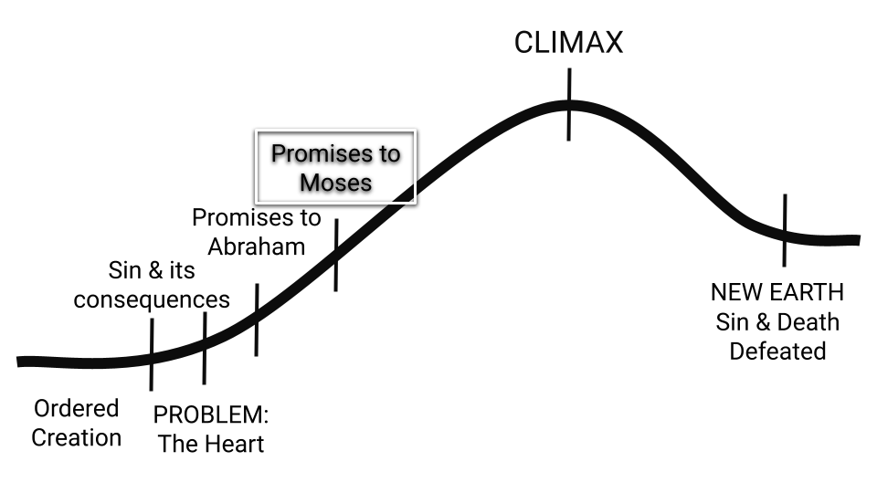
Figure 5.1: Plot arc - Exodus
THE STORY BETWEEN THE PROMISES
NUMBER THREE

When Moses invited the people of Israel into this covenant relationship with God, they confidently asserted, “All that the Lord says we will do” (Exodus 19:8, Exodus 24:3). Shortly after Moses goes up the mountain, however, they disregard these words and start worshipping a golden calf. It is evident that they cannot and will not completely obey the LORD, and yet the LORD has committed Himself to fulfilling His promises to Abraham and to blessing the world through these people.

How will the LORD be able to fulfill His promises? Once again, God must initiate a rescue operation. In the month following the golden calf incident, He implements a way for people to be rescued from the consequences of sin, by offering a method of atonement.

If you look back to Exodus 32:30, you will see these words, “The next day Moses said to the people, “You have committed a great sin. But now I will go up to the Lord; perhaps I can make atonement for your sin.”

What does he mean when he says this? Well in Exodus 32:31 we read, “So Moses went back to the Lord and said, ‘Oh, what a great sin these people have committed! They have made themselves gods of gold. 32 But now, please forgive their sin—but if not, then blot me out of the book you have written.’ ”
Moses is hoping to make “atonement” for the sins of the people by offering himself as a substitute.

In reply, the LORD proclaims, “Whoever has sinned against me I will blot out of my book.” (Exodus 32:33). In other words, He tells Moses that one person cannot pay for the sins of another - each person must be responsible for their own sins.

Despite this ruling on sin, God does provide a way for them to receive atonement: through the sacrificial system.

The Solution of God - Promises to Moses (Part 2)

The Day of Atonement
Before we read the direction that God gives to Moses regarding the Day of Atonement, we want to have the setting of this annual event in our minds. The most concise explanation of the setting appears in the New Testament - in Hebrews 9:1-7

Read the Bible passages below and answer the questions that follow.

1. The Setting

God’s Tabernacle: The Holy Place and Most Holy Place

Hebrews 9:1-7

¹Now the first covenant had regulations for worship and also an earthly sanctuary. ² A tabernacle was set up. In its first room were the lampstand and the table with its consecrated bread; this was called the Holy Place. ³ Behind the second curtain was a room called the Most Holy Place, ⁴ which had the golden altar of incense and the gold-covered ark of the covenant. This ark contained the gold jar of manna, Aaron’s staff that had budded, and the stone tablets of the covenant. ⁵ Above the ark were the cherubim of the Glory, overshadowing the atonement cover. But we cannot discuss these things in detail now.
⁶ When everything had been arranged like this, the priests entered regularly into the outer room to carry on their ministry. ⁷ But only the high priest entered the inner room, and that only once a year, and never without blood, which he offered for himself and for the sins the people had committed in ignorance.

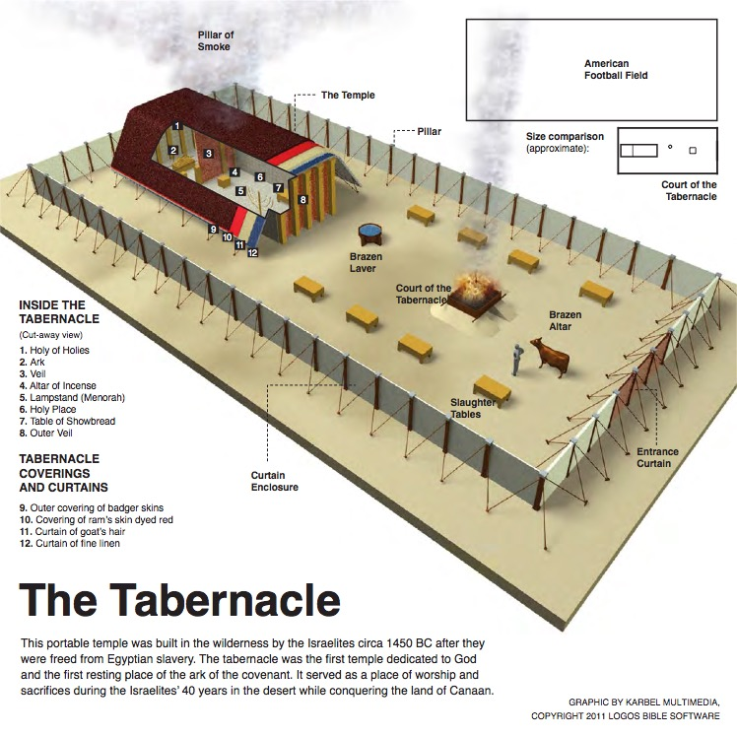
Figure 6.1: The Tabernacle. This portable temple was built in the wilderness by the Israelites circa 1450 BC after they were freed from Egyptian slavery. The tabernacle was the first temple dedicated to God and the first resting place of the ark of the covenant. It served as a place of worship and sacrifices during the Israelites’ 40 years in the desert while conquering the land of Canaan.

1. The Setting continued...

God’s Tabernacle: The Holy Place and Most Holy Place
  - What items are in the Holy Place? (v 2)
  - What items are in the Most Holy Place? (v 3-5)
  - How often are priests allowed in the outer room (Holy Place)?
  - Who is allowed in the inner room (Most Holy Place) and how often?
  - What must the High Priest bring with him into the Most Holy Place and what is its purpose?

2. The Day of Atonement
With these details in mind, read the LORD’s instructions to Moses in Leviticus 16. This can be a really confusing chapter to read, so we’ll help you make sense of it. As you read these verses, fill in the blanks on pages 66-67.
Leviticus 16

¹ The Lord spoke to Moses after the death of the two sons of Aaron who died when they approached the Lord. ² The Lord said to Moses: “Tell your brother Aaron that he is not to come whenever he chooses into the Most Holy Place behind the curtain in front of the atonement cover on the ark, or else he will die. For I will appear in the cloud over the atonement cover.

³ “This is how Aaron is to enter the Most Holy Place: He must first bring a young bull for a sin offering and a ram for a burnt offering. ⁴ He is to put on the sacred linen tunic, with linen undergarments next to his body; he is to tie the linen sash around him and put on the linen turban. These are sacred garments; so he must bathe himself with water before he puts them on. ⁵ From the Israelite community he is to take two male goats for a sin offering and a ram for a burnt offering.

⁶ “Aaron is to offer the bull for his own sin offering to make atonement for himself and his household. ⁷ Then he is to take the two goats and present them before the Lord at the entrance to the tent of meeting. ⁸ He is to cast lots for the two goats—one lot for the Lord and the other for the scapegoat. ⁹ Aaron shall bring the goat whose lot falls to the Lord and sacrifice it for a sin offering. ¹⁰ But the goat chosen by lot as the scapegoat shall be presented alive before the Lord to be used for making atonement by sending it into the wilderness as a scapegoat.

¹¹ “Aaron shall bring the bull for his own sin offering to make atonement for himself and his household, and he is to slaughter the bull for his own sin offering. ¹² He is to take a censer full of burning coals from the altar before the Lord and two handfuls of finely ground fragrant incense and take them behind the curtain. ¹³ He is to put the incense on the fire before the Lord, and the smoke of the incense will conceal the atonement cover above the tablets of the covenant law, so that he will not die. ¹⁴ He is to take some of the bull’s blood and with his finger sprinkle it on the front of the atonement cover; then he shall sprinkle some of it with his finger seven times before the atonement cover.

¹⁵ “He shall then slaughter the goat for the sin offering for the people and take its blood behind the curtain and do with it as he did with the bull’s blood: He shall sprinkle it on the atonement cover and in front of it. ¹⁶ In this way he will make atonement for the Most Holy Place because of the uncleanness and rebellion of the Israelites, whatever their sins have been. He is to do the same for the tent of meeting, which is among them in the midst of their uncleanness. ¹⁷ No one is to be in the tent of meeting from the time Aaron goes in to make atonement in the Most Holy Place until he comes out, having made atonement for himself, his household and the whole community of Israel.

¹⁸ “Then he shall come out to the altar that is before the Lord and make atonement for it. He shall take some of the bull’s blood and some of the goat’s blood and put it on all the horns of the altar. ¹⁹ He shall sprinkle some of the blood on it with his finger seven times to cleanse it and to consecrate it from the uncleanness of the Israelites.

²⁰ “When Aaron has finished making atonement for the Most Holy Place, the tent of meeting and the altar, he shall bring forward the live goat. ²¹ He is to lay both hands on the head of the live goat and confess over it all the wickedness and rebellion of the Israelites—all their sins—and put them on the goat’s head. He shall send the goat away into the wilderness in the care of someone appointed for the task. ²² The goat will carry on itself all their sins to a remote place; and the man shall release it in the wilderness.

²³ “Then Aaron is to go into the tent of meeting and take off the linen garments he put on before he entered the Most Holy Place, and he is to leave them there. ²⁴ He shall bathe himself with water in the sanctuary area and put on his regular garments. Then he shall come out and sacrifice the burnt offering for himself and the burnt offering for the people, to make atonement for himself and for the people. ²⁵ He shall also burn the fat of the sin offering on the altar.

²⁶ “The man who releases the goat as a scapegoat must wash his clothes and bathe himself with water; afterward he may come into the camp. ²⁷ The bull and the goat for the sin offerings, whose blood was brought into the Most Holy Place to make atonement, must be taken outside the camp; their hides, flesh and intestines are to be burned up. ²⁸ The man who burns them must wash his clothes and bathe himself with water; afterward he may come into the camp.

²⁹ “This is to be a lasting ordinance for you: On the tenth day of the seventh month you must deny yourselves and not do any work—whether native-born or a foreigner residing among you— ³⁰ because on this day atonement will be made for you, to cleanse you. Then, before the Lord, you will be clean from all your sins. ³¹ It is a day of sabbath rest, and you must deny yourselves; it is a lasting ordinance. ³² The priest who is anointed and ordained to succeed his father as high priest is to make atonement. He is to put on the sacred linen garments ³³ and make atonement for the Most Holy Place, for the tent of meeting and the altar, and for the priests and all the members of the community.

3⁴ “This is to be a lasting ordinance for you: Atonement is to be made once a year for all the sins of the Israelites.” And it was done, as the Lord commanded Moses.

2. The Day of Atonement continued...
Fill in the blanks.
First Animal: ___________________________________ (v 3)
- What type of offering is this animal? (v 3)

- This animal is a sacrifice for whom? (v 6)

- How is this animal sacrificed? List what happens (v 11-14, v 18-19, v 27)

- Where is this animal sacrificed? (v 12)

Second Animal: ___________________________________ (v 3)
- What type of offering is this animal? (v 3)

- This animal is a sacrifice for whom? (v 24)

- How does Aaron prepare himself for this animal sacrifice? List what happens (v 24-25)

- Where is this animal sacrificed? (v 25)

Third, Fourth and Fifth Animals: ___________________________________ (v 5)
- What type of offering are the goats? (v 5)

- What type of offering is the ram? (v 5)

- What happens to the goats? (v 8 - 10)

  - Goat #1 - The goat whose lot falls to the LORD (v 15 - 19)
    - In which 2 places are the blood sprinkled? (v 15, v 18-19)

    - What does the sacrifice accomplish? (v 16)

  - Goat #2 - The goat chosen by lot as the scapegoat
    - What happens to this goat? (v 20-22)

- How is the ram sacrificed? (v 24-25)

  - Why is the ram sacrificed? (v 24)

- The sins of the people are atoned for by both the killed goat and the scapegoat. How does the experience of each goat symbolize what Jesus will eventually do to solve the problem of sin?

- How successful was the Day of Atonement at addressing the problem of sin? (v 29-34) If you want to see a New Testament evaluation on the Day of Atonement, read Hebrews 9:9-14.

- What has this lesson taught you about who God is?

- What has this lesson taught you about what God does to balance justice (the requirement to punish sin) and mercy (to forgive people who sin)?

- What has this lesson taught you about the seriousness of sin, and how it can be atoned for?

Large Group Teaching

God Goes with His People but is Clear about His Terms
Lesson 6: The Solution of God - Promises to Moses (Part 2)

God Goes with His People - Exodus 40:17-38

God is Clear about His Terms - Leviticus 26:1-17

Exodus 40:17-38 - God Goes with His People

¹⁷ So the tabernacle was set up on the first day of the first month in the second year. ¹⁸ When Moses set up the tabernacle, he put the bases in place, erected the frames, inserted the crossbars and set up the posts. ¹⁹ Then he spread the tent over the tabernacle and put the covering over the tent, as the Lord commanded him.

²⁰ He took the tablets of the covenant law and placed them in the ark, attached the poles to the ark and put the atonement cover over it. ²¹ Then he brought the ark into the tabernacle and hung the shielding curtain and shielded the ark of the covenant law, as the Lord commanded him.

²² Moses placed the table in the tent of meeting on the north side of the tabernacle outside the curtain ²³ and set out the bread on it before the Lord, as the Lord commanded him.

²⁴ He placed the lampstand in the tent of meeting opposite the table on the south side of the tabernacle ²⁵ and set up the lamps before the Lord, as the Lord commanded him.

²⁶ Moses placed the gold altar in the tent of meeting in front of the curtain ²⁷ and burned fragrant incense on it, as the Lord commanded him.

²⁸ Then he put up the curtain at the entrance to the tabernacle. ²⁹ He set the altar of burnt offering near the entrance to the tabernacle, the tent of meeting, and offered on it burnt offerings and grain offerings, as the Lord commanded him.

³⁰ He placed the basin between the tent of meeting and the altar and put water in it for washing, ³¹ and Moses and Aaron and his sons used it to wash their hands and feet. ³² They washed whenever they entered the tent of meeting or approached the altar, as the Lord commanded Moses.

³³ Then Moses set up the courtyard around the tabernacle and altar and put up the curtain at the entrance to the courtyard. And so Moses finished the work.

³⁴ Then the cloud covered the tent of meeting, and the glory of the Lord filled the tabernacle. ³⁵ Moses could not enter the tent of meeting because the cloud had settled on it, and the glory of the Lord filled the tabernacle.

³⁶ In all the travels of the Israelites, whenever the cloud lifted from above the tabernacle, they would set out; ³⁷ but if the cloud did not lift, they did not set out—until the day it lifted. ³⁸ So the cloud of the Lord was over the tabernacle by day, and fire was in the cloud by night, in the sight of all the Israelites during all their travels.

Leviticus 26 - God is Clear about His Terms

¹“‘Do not make idols or set up an image or a sacred stone for yourselves, and do not place a carved stone in your land to bow down before it. I am the Lord your God.

² “‘Observe my Sabbaths and have reverence for my sanctuary. I am the Lord.

³ “‘If you follow my decrees and are careful to obey my commands, ⁴ I will send you rain in its season, and the ground will yield its crops and the trees their fruit. ⁵ Your threshing will continue until grape harvest and the grape harvest will continue until planting, and you will eat all the food you want and live in safety in your land.

⁶ “‘I will grant peace in the land, and you will lie down and no one will make you afraid. I will remove wild beasts from the land, and the sword will not pass through your country. ⁷ You will pursue your enemies, and they will fall by the sword before you. ⁸ Five of you will chase a hundred, and a hundred of you will chase ten thousand, and your enemies will fall by the sword before you.

⁹ “‘I will look on you with favor and make you fruitful and increase your numbers, and I will keep my covenant with you. ¹⁰ You will still be eating last year’s harvest when you will have to move it out to make room for the new. ¹¹ I will put my dwelling place among you, and I will not abhor you. ¹² I will walk among you and be your God, and you will be my people. ¹³ I am the Lord your God, who brought you out of Egypt so that you would no longer be slaves to the Egyptians; I broke the bars of your yoke and enabled you to walk with heads held high.

¹⁴ “‘But if you will not listen to me and carry out all these commands, ¹⁵ and if you reject my decrees and abhor my laws and fail to carry out all my commands and so violate my covenant, ¹⁶ then I will do this to you: I will bring on you sudden terror, wasting diseases and fever that will destroy your sight and sap your strength. You will plant seed in vain, because your enemies will eat it. ¹⁷ I will set my face against you so that you will be defeated by your enemies; those who hate you will rule over you, and you will flee even when no one is pursuing you.

¹⁸ “‘If after all this you will not listen to me, I will punish you for your sins seven times over. ¹⁹ I will break down your stubborn pride and make the sky above you like iron and the ground beneath you like bronze. ²⁰ Your strength will be spent in vain, because your soil will not yield its crops, nor will the trees of your land yield their fruit.

²¹ “‘If you remain hostile toward me and refuse to listen to me, I will multiply your afflictions seven times over, as your sins deserve. ²² I will send wild animals against you, and they will rob you of your children, destroy your cattle and make you so few in number that your roads will be deserted.

²³ “‘If in spite of these things you do not accept my correction but continue to be hostile toward me, ²⁴ I myself will be hostile toward you and will afflict you for your sins seven times over. ²⁵ And I will bring the sword on you to avenge the breaking of the covenant. When you withdraw into your cities, I will send a plague among you, and you will be given into enemy hands. ²⁶ When I cut off your supply of bread, ten women will be able to bake your bread in one oven, and they will dole out the bread by weight. You will eat, but you will not be satisfied.

²⁷ “‘If in spite of this you still do not listen to me but continue to be hostile toward me, ²⁸ then in my anger I will be hostile toward you, and I myself will punish you for your sins seven times over. ²⁹ You will eat the flesh of your sons and the flesh of your daughters. ³⁰ I will destroy your high places, cut down your incense altars and pile your dead bodies on the lifeless forms of your idols, and I will abhor you. ³¹ I will turn your cities into ruins and lay waste your sanctuaries, and I will take no delight in the pleasing aroma of your offerings. ³² I myself will lay waste the land, so that your enemies who live there will be appalled. ³³ I will scatter you among the nations and will draw out my sword and pursue you. Your land will be laid waste, and your cities will lie in ruins. ³⁴ Then the land will enjoy its sabbath years all the time that it lies desolate and you are in the country of your enemies; then the land will rest and enjoy its sabbaths. ³⁵ All the time that it lies desolate, the land will have the rest it did not have during the sabbaths you lived in it.

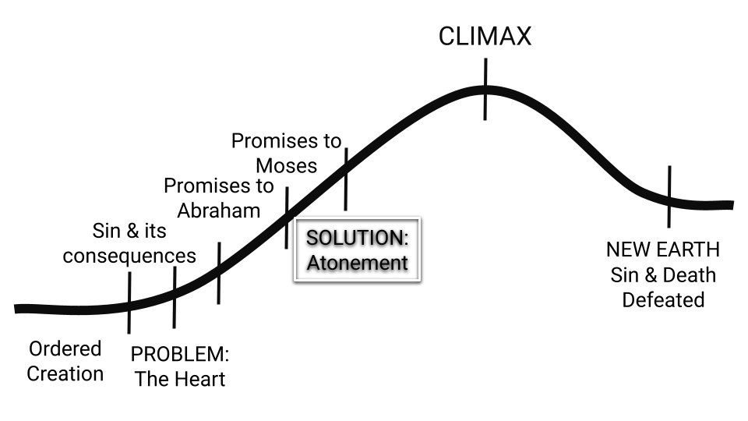
Figure 6.2: Plot arc - Leviticus

THE STORY BETWEEN THE PROMISES
NUMBER FOUR

After the tabernacle was built, and God provided his people with the laws for governing their nation and a method for dealing with their sin, the Israelites set out on their journey towards Canaan (Numbers 10:11). As they came near to the land, however, they became fearful of its current inhabitants, and rebelled against Moses’ leadership. Consequently, God decreed that they would wander in the wilderness for forty years, until the current generation of Israelite adults died (Numbers 14:26-35).

God chose Joshua to lead the nation after Moses (Deuteronomy 31:14-23, Deuteronomy 34:1-10). Joshua was able to lead them into Canaan and to win some military battles which allowed them to settle in the land, but they did not gain full possession of it. They lived side by side with people of other nationalities and other faiths, and soon forgot to follow the LORD (Judges 2:6-15). For several generations, the Israelites lived a cyclical existence: they would follow other gods, the LORD would send an enemy army against them to judge them for their disobedience, they would then cry out to the LORD for rescue and He would appoint a judge to deliver them. For a time they would follow the LORD, but eventually they would follow other gods and the cycle would continue. The book of Judges ends with a hint that, perhaps a different kind of leader would help Israel to obey: “In those days Israel had no king; everyone did as they saw fit” (Judges 21:25).

Will a king help the Israelites to obey and obtain the blessings promised in Leviticus 26?? Maybe and maybe not.

In the book of 1 Samuel the people asked Samuel (Israel’s final judge) for a king and God concedes (1 Samuel 8). King Saul was appointed and showed a few moments of promise, before revealing that he valued his own status more than honoring the LORD. He was rejected by God as king, and God asked Samuel to anoint David as king instead (1 Samuel 15-16). For many years Saul attempted to kill David but eventually he died and David ascended to the throne (2 Samuel 5:1-5).

As David’s kingdom solidified and Israel experienced peace, God unveiled the next step in his plan of redemption in a new set of promises.

REVIEW

In Genesis 1-11 we learn about creation, people’s rebellion against God, and God’s assessment of humanity: there is a problem with the human heart.

In Genesis 12 the story of redemption began with unconditional promises made to Abraham.

The nation of Israel will…
- be blessed
- become a great nation
- be given a land

Through the nation of Israel…
- the world will be blessed.

In Exodus to 2 Samuel the story of redemption continued with promises made to Moses. While
the promises to Abraham were unconditional, the blessings promised through Moses are conditional. The people of Israel will obtain God’s blessings if they obey and will be punished if they disobey. These nine books of law and history relate stories which demonstrate that God is true to his promises: giving them both blessing and cursing according to their actions.

In these nine books the nation of Israel...
- was blessed when they obeyed, cursed when they disobeyed
- became a great nation
- experienced peace in the land
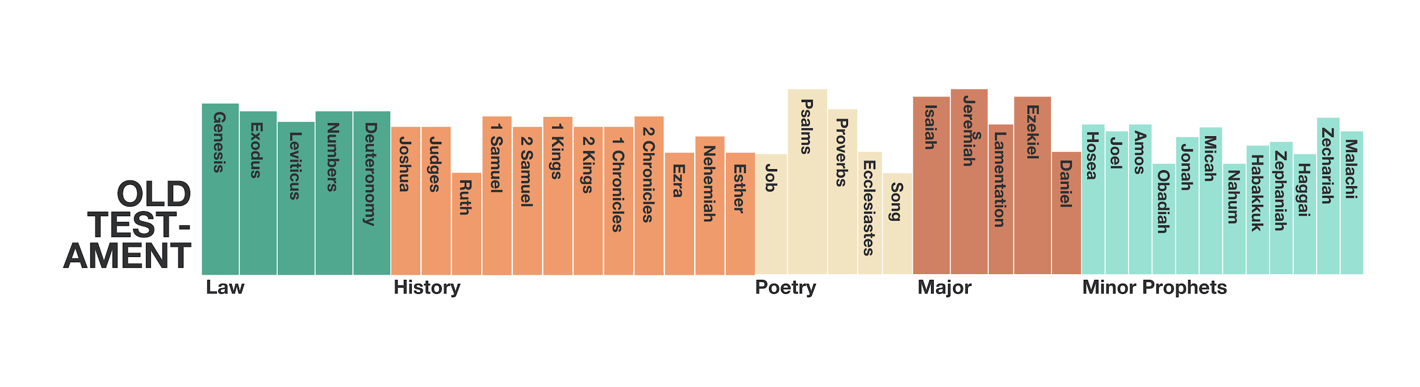
Figure 6.3: Bible by Genre

The Solution of God - Promises to David

1. Promises to David

Read the Bible passages below and answer the questions that follow.

2 Samuel 7:1-16
¹ After the king was settled in his palace and the Lord had given him rest from all his enemies around him, ² he said to Nathan the prophet, “Here I am, living in a house of cedar, while the ark of God remains in a tent.” ³ Nathan replied to the king, “Whatever you have in mind, go ahead and do it, for the Lord is with you.”
⁴ But that night the word of the Lord came to Nathan, saying: ⁵ “Go and tell my servant David, ‘This is what the LORD says: Are you the one to build me a house to dwell in? ⁶ I have not dwelt in a house from the day I brought the Israelites up out of Egypt to this day. I have been moving from place to place with a tent as my dwelling. ⁷ Wherever I have moved with all the Israelites, did I ever say to any of their rulers whom I commanded to shepherd my people Israel, “Why have you not built me a house of cedar?”’
⁸ “Now then, tell my servant David, ‘This is what the LORD Almighty says: I took you from the pasture, from tending the flock, and appointed you ruler over my people Israel. ⁹ I have been with you wherever you have gone, and I have cut off all your enemies from before you. Now I will make your name great, like the names of the greatest men on earth. ¹⁰ And I will provide a place for my people Israel and will plant them so that they can have a home of their own and no longer be disturbed. Wicked people will not oppress them anymore, as they did at the beginning ¹¹ and have done ever since the time I appointed leaders over my people Israel. I will also give you rest from all your enemies.
“‘The LORD declares to you that the LORD himself will establish a house for you: ¹² When your days are over and you rest with your ancestors, I will raise up your offspring to succeed you, your own flesh and blood, and I will establish his kingdom. ¹³ He is the one who will build a house for my Name, and I will establish the throne of his kingdom forever. ¹⁴ I will be his father, and he will be my son. When he does wrong, I will punish him with a rod wielded by men, with floggings inflicted by human hands. ¹⁵ But my love will never be taken away from him, as I took it away from Saul, whom I removed from before you. ¹⁶ Your house and your kingdom will endure forever before me; your throne will be established forever.’”

1. Promises to David continued...
  - What was David feeling uneasy about as this chapter opens?

  - Based on what the LORD says to Nathan in 2 Samuel 7:5-6, what was David thinking of doing?

  - How does the LORD change David’s focus in verses 8-9a? What does he remind him of?

  - List what the LORD promises to David in verses 9b-11, and then compare these promises with the promises made to Abraham in Genesis 12:1-3. What similarities do you see?

    - What does it mean that the Lord will establish a “house” for David?

    - Based on what we read in “The Story between the Promises #4”, why is this “house” important? (eg. What should future kings help Israel do, and why is this important?)

  - In 2 Samuel 7:11-16 the LORD adds new promises to Israel’s narrative. What are they?

    - Are these promises conditional or unconditional? How do you know?

2. David’s Response to the Promises

2 Samuel 7:17-29

¹⁷ Nathan reported to David all the words of this entire revelation.

¹⁸ Then King David went in and sat before the Lord, and he said:

“Who am I, Sovereign Lord, and what is my family, that you have brought me this far? ¹⁹ And as if this were not enough in your sight, Sovereign Lord, you have also spoken about the future of the house of your servant—and this decree, Sovereign Lord, is for a mere human!

²⁰ “What more can David say to you? For you know your servant, Sovereign Lord. ²¹ For the sake of your word and according to your will, you have done this great thing and made it known to your servant.

²² “How great you are, Sovereign Lord! There is no one like you, and there is no God but you, as we have heard with our own ears. ²³ And who is like your people Israel—the one nation on earth that God went out to redeem as a people for himself, and to make a name for himself, and to perform great and awesome wonders by driving out nations and their gods from before your people, whom you redeemed from Egypt? ²⁴ You have established your people Israel as your very own forever, and you, Lord, have become their God.

²⁵ “And now, Lord God, keep forever the promise you have made concerning your servant and his house. Do as you promised, ²⁶ so that your name will be great forever. Then people will say, ‘The Lord Almighty is God over Israel!’ And the house of your servant David will be established in your sight.

²⁷ “Lord Almighty, God of Israel, you have revealed this to your servant, saying, ‘I will build a house for you.’ So your servant has found courage to pray this prayer to you. ²⁸ Sovereign Lord, you are God! Your covenant is trustworthy, and you have promised these good things to your servant. ²⁹ Now be pleased to bless the house of your servant, that it may continue forever in your sight; for you, Sovereign Lord, have spoken, and with your blessing the house of your servant will be blessed forever.”

2. David’s Response to the Promises continued…

- How does David respond to the LORD’s promises?
    - What are the primary emotion(s) evident in David’s response?

    - What does he affirm about himself?

    - What does he affirm about the LORD?

    - What does he ask for? And why does he ask for this?

      - How does David’s perspective of himself challenge or encourage you today?

      - How does David’s perspective of the LORD challenge or encourage you today?

3. God’s Promises Fulfilled

1 Kings 4:20-34 - After David passed away, his son Solomon took the throne, and the LORD began fulfilling His promises to David.

²⁰ The people of Judah and Israel were as numerous as the sand on the seashore; they ate, they drank and they were happy. ²¹ And Solomon ruled over all the kingdoms from the Euphrates River to the land of the Philistines, as far as the border of Egypt. These countries brought tribute and were Solomon’s subjects all his life...

²⁴ For he ruled over all the kingdoms west of the Euphrates River, from Tiphsah to Gaza, and had peace on all sides. ²⁵ During Solomon’s lifetime Judah and Israel, from Dan to Beersheba, lived in safety, everyone under their own vine and under their own fig tree.

²⁶ Solomon had four thousand stalls for chariot horses, and twelve thousand horses…²⁹ God gave Solomon wisdom and very great insight, and a breadth of understanding as measureless as the sand on the seashore. ³⁰ Solomon’s wisdom was greater than the wisdom of all the people of the East, and greater than all the wisdom of Egypt. ³¹ He was wiser than anyone else, including Ethan the Ezrahite—wiser than Heman, Kalkol and Darda, the sons of Mahol. And his fame spread to all the surrounding nations. ³² He spoke three thousand proverbs and his songs numbered a thousand and five. ³³ He spoke about plant life, from the cedar of Lebanon to the hyssop that grows out of walls. He also spoke about animals and birds, reptiles and fish. ³⁴ From all nations people came to listen to Solomon’s wisdom, sent by all the kings of the world, who had heard of his wisdom.
1 Kings 6:1

¹ In the four hundred and eightieth year after the Israelites came out of Egypt, in the fourth year of Solomon’s reign over Israel, in the month of Ziv, the second month, he began to build the temple of the Lord.
1 Kings 8:1-11 - Dedication of the Temple - 966 BC
¹ Then King Solomon summoned into his presence at Jerusalem the elders of Israel, all the heads of the tribes and the chiefs of the Israelite families, to bring up the ark of the Lord’s covenant from Zion, the City of David. ² All the Israelites came together to King Solomon at the time of the festival in the month of Ethanim, the seventh month…
⁶ The priests then brought the ark of the Lord’s covenant to its place in the inner sanctuary of the temple, the Most Holy Place, and put it beneath the wings of the cherubim…
¹⁰ When the priests withdrew from the Holy Place, the cloud filled the temple of the Lord. ¹¹ And the priests could not perform their service because of the cloud, for the glory of the Lord filled his temple.

3. God’s Promises Fulfilled continued...
        - Which of the promises to Abraham, Moses and David are fulfilled in 1 Kings 4:20-34?

          - What does this teach us about kings like David & Solomon?

        - What happens after Solomon builds and dedicates the temple in 1 Kings 6 and 8?

          - What is the significance of his presence filling the temple? (need a hint? see Leviticus 26:9-13)

        - How is your faith impacted by reading these historical accounts which affirm that God fulfilled all his promises to his people?

Large Group Teaching
Lesson 7: The Solution of God - Promises to David

God fulfills his Promises, but the Problem of the Heart remains

1 Kings 11:1-12

¹ King Solomon, however, loved many foreign women besides Pharaoh’s daughter—Moabites, Ammonites, Edomites, Sidonians and Hittites. ² They were from nations about which the Lord had told the Israelites, “You must not intermarry with them, because they will surely turn your hearts after their gods.” Nevertheless, Solomon held fast to them in love. ³ He had seven hundred wives of royal birth and three hundred concubines, and his wives led him astray. ⁴ As Solomon grew old, his wives turned his heart after other gods, and his heart was not fully devoted to the Lord his God, as the heart of David his father had been…

⁹ The Lord became angry with Solomon because his heart had turned away from the Lord, the God of Israel, who had appeared to him twice. ¹⁰ Although he had forbidden Solomon to follow other gods, Solomon did not keep the Lord’s command. ¹¹ So the Lord said to Solomon, “Since this is your attitude and you have not kept my covenant and my decrees, which I commanded you, I will most certainly tear the kingdom away from you and give it to one of your subordinates. ¹² Nevertheless, for the sake of David your father, I will not do it during your lifetime. I will tear it out of the hand of your son. ¹³ Yet I will not tear the whole kingdom from him, but will give him one tribe for the sake of David my servant and for the sake of Jerusalem, which I have chosen.”
922 BC - Israel is Split into 2 Kingdoms. The Northern Kingdom (10 Tribes), and the Southern Kingdom (2 Tribes)
2 Kings 17:1-20 - First exile (Northern Kingdom) - 722 BC

¹In the twelfth year of Ahaz king of Judah... ⁵ The king of Assyria invaded the entire land, marched against Samaria and laid siege to it for three years. ⁶ In the ninth year of Hoshea, the king of Assyria captured Samaria and deported the Israelites to Assyria. He settled them in Halah, in Gozan on the Habor River and in the towns of the Medes.

⁷ All this took place because the Israelites had sinned against the Lord their God, who had brought them up out of Egypt from under the power of Pharaoh king of Egypt. They worshiped other gods ⁸ and followed the practices of the nations the Lord had driven out before them, as well as the practices that the kings of Israel had introduced. ⁹ The Israelites secretly did things against the Lord their God that were not right. From watchtower to fortified city they built themselves high places in all their towns. ¹⁰ They set up sacred stones and Asherah poles on every high hill and under every spreading tree. ¹¹ At every high place they burned incense, as the nations whom the Lord had driven out before them had done. They did wicked things that aroused the Lord’s anger. ¹² They worshiped idols, though the Lord had said, “You shall not do this.” ¹³ The Lord warned Israel and Judah through all his prophets and seers: “Turn from your evil ways. Observe my commands and decrees, in accordance with the entire Law that I commanded your ancestors to obey and that I delivered to you through my servants the prophets.”

¹⁴ But they would not listen and were as stiff-necked as their ancestors, who did not trust in the Lord their God.

¹⁸ So the Lord was very angry with Israel and removed them from his presence. Only the tribe of Judah was left, ¹⁹ and even Judah did not keep the commands of the Lord their God. They followed the practices Israel had introduced. ²⁰ Therefore the Lord rejected all the people of Israel; he afflicted them and gave them into the hands of plunderers, until he thrust them from his presence.
2 Kings 25:5-12 - 2nd Exile (Southern Kingdom) - 597 & 587 BC

⁸ On the seventh day of the fifth month, in the nineteenth year of Nebuchadnezzar king of Babylon, Nebuzaradan commander of the imperial guard, an official of the king of Babylon, came to Jerusalem. ⁹ He set fire to the temple of the Lord, the royal palace and all the houses of Jerusalem. Every important building he burned down. ¹⁰ The whole Babylonian army under the commander of the imperial guard broke down the walls around Jerusalem. ¹¹ Nebuzaradan the commander of the guard carried into exile the people who remained in the city, along with the rest of the populace and those who had deserted to the king of Babylon. ¹² But the commander left behind some of the poorest people of the land to work the vineyards and fields.
Ezekiel 10:18-19 - God’s Spirit Departs from the Temple

¹⁸ Then the glory of the Lord departed from over the threshold of the temple and stopped above the cherubim. ¹⁹ While I watched, the cherubim spread their wings and rose from the ground, and as they went, the wheels went with them. They stopped at the entrance of the east gate of the Lord’s house, and the glory of the God of Israel was above them.
Ezekiel 11:22-23 - God’s Spirit Departs from Jerusalem

²² Then the cherubim, with the wheels beside them, spread their wings, and the glory of the God of Israel was above them. ²³ The glory of the Lord went up from within the city and stopped above the mountain east of it.

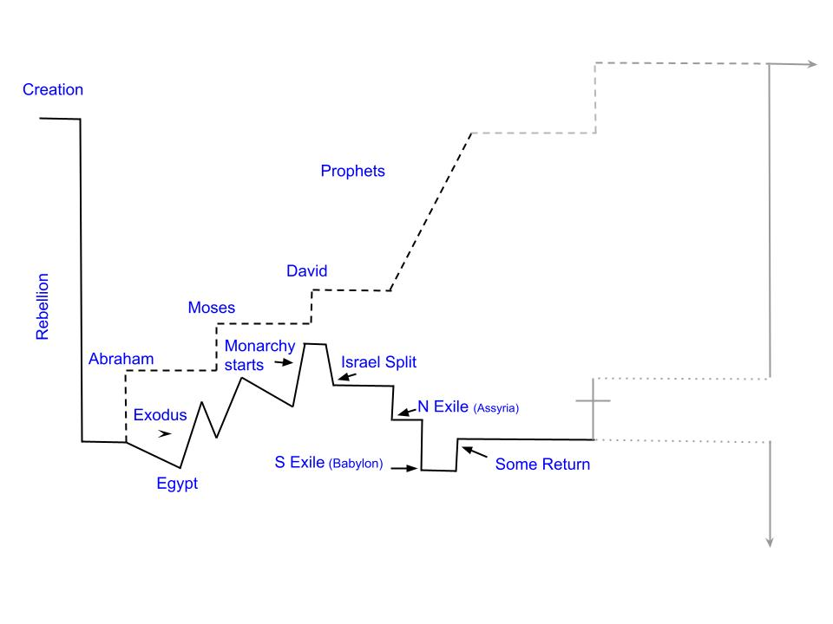
Figure 7.1: Intersection of Biblical Timeline & Promises
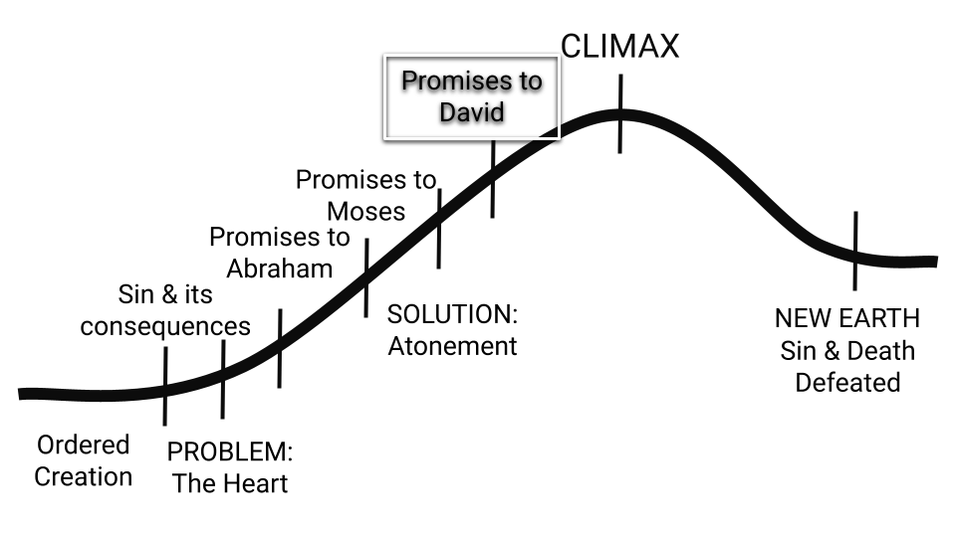
Figure 7.2: Plot arc - At the end of Kings & Chronicles

THE STORY BETWEEN THE PROMISES
NUMBER FIVE

David’s kingdom is dated to roughly 1010 BC. After his reign, as Israel becomes an established nation, the dating of biblical events becomes more precise because the kingdoms of Israel and Judah are mentioned in the literature of other nations such as Moab, Assyria and Babylonia.

Solomon’s dedication of the temple is dated to 966 BC, and his reign ends approximately 930 BC. By 922 BC, the nation was split in two, and within two hundred years (722 BC), the northern kingdom was decimated by Assyria. A series of disobedient kings had led the people away from following the LORD, and so the LORD removed them from the land.

One hundred and fifty years later, the southern kingdom was defeated by Babylon in two stages (597 BC and 587 BC). The temple was destroyed, God’s spirit departed, and the people were taken into captivity. The Biblical writers refer to these events as the “exile”.
In the events of 1 Kings to 2 Chronicles we read that God was true to his promise of providing both blessings and cursings. In the Historical books of Ezra, Nehemiah and Esther which follow, Biblical authors tell the story of the LORD taking care of his people after the exile, when some are allowed to return to the land of Israel.
Between 922 BC and 400 BC, prophets began speaking! The stories of the first significant prophets (Elijah and Elisha) are told within the narratives of 1 and 2 Kings. From about 800 BC onwards, the words of prophets like Isaiah were recorded within stand-alone biblical books. Since the kings were not leading the people in obedience, the LORD sent prophets to preach His word to the kings and to the people - reminding them of the blessing and curses promised through Moses, and warning them to turn back to the LORD and follow him whole-heartedly. Most prophets spoke before and during the exile, but the last three (Haggai, Zechariah and Malachi) were sent by God to those who returned to Israel after the exile. They continued to call God’s people to obedience and to hold out future hope of both blessing and cursing.

In the wake of their national disaster, the prophets painted a picture of how God would finally solve the problem of the heart, and redeem his people from slavery to sin. That is what we will study next!

Figure 7.3: Bible by Genre

The Solution of God - Promises through Prophets

Read the Bible passages below and answer the questions that follow.

1. Promises through the Prophets: A New Covenant

Ezekiel 36:24-28

²⁴ “‘For I will take you out of the nations; I will gather you from all the countries and bring you back into your own land. ²⁵ I will sprinkle clean water on you, and you will be clean; I will cleanse you from all your impurities and from all your idols. ²⁶ I will give you a new heart and put a new spirit in you; I will remove from you your heart of stone and give you a heart of flesh. ²⁷ And I will put my Spirit in you and move you to follow my decrees and be careful to keep my laws. ²⁸ Then you will live in the land I gave your ancestors; you will be my people, and I will be your God.

Jeremiah 31:31-34

³¹ “The days are coming,” declares the Lord,

“when I will make a new covenant

with the people of Israel

and with the people of Judah.

³² It will not be like the covenant

I made with their ancestors

when I took them by the hand

to lead them out of Egypt,

because they broke my covenant,

though I was a husband to them,”

declares the Lord.

³³ “This is the covenant I will make with the people of Israel

after that time,” declares the Lord.

“I will put my law in their minds

and write it on their hearts.

I will be their God,

and they will be my people.

³⁴ No longer will they teach their neighbor,

or say to one another, ‘Know the Lord,’

because they will all know me,

from the least of them to the greatest,”

declares the Lord.

“For I will forgive their wickedness

and will remember their sins no more.”

Promises through the Prophets: A New Covenant continued...
  - What is the “problem” with the old covenant according to Jeremiah?

  - What is the promise of the new covenant according to both Ezekiel & Jeremiah? List everything that these prophets relate about what the LORD will do in the future.

    - Based on what we have studied so far, why is it necessary for God to do these things?

  - What is the difference between the promise made in Ezekiel 36:25 and the promises in 36:26-27?

    - Why are both promises necessary?

  - We’ll get into when this promise was fulfilled in the next lesson, but right now I’d invite you to stop to examine the state of your own heart. Do you have a heart of stone or a heart of flesh? How do you know?

2. Promises through the Prophets: A New Leader (Part 1)

Ezekiel 34:1-10

¹ The word of the Lord came to me: ² “Son of man, prophesy against the shepherds of Israel; prophesy and say to them: ‘This is what the Sovereign Lord says: Woe to you shepherds of Israel who only take care of yourselves! Should not shepherds take care of the flock? ³ You eat the curds, clothe yourselves with the wool and slaughter the choice animals, but you do not take care of the flock. ⁴ You have not strengthened the weak or healed the sick or bound up the injured. You have not brought back the strays or searched for the lost. You have ruled them harshly and brutally. ⁵ So they were scattered because there was no shepherd, and when they were scattered they became food for all the wild animals. ⁶ My sheep wandered over all the mountains and on every high hill. They were scattered over the whole earth, and no one searched or looked for them.

⁷ “‘Therefore, you shepherds, hear the word of the Lord: ⁸ As surely as I live, declares the Sovereign Lord, because my flock lacks a shepherd and so has been plundered and has become food for all the wild animals, and because my shepherds did not search for my flock but cared for themselves rather than for my flock, ⁹ therefore, you shepherds, hear the word of the Lord: ¹⁰ This is what the Sovereign Lord says: I am against the shepherds and will hold them accountable for my flock. I will remove them from tending the flock so that the shepherds can no longer feed themselves. I will rescue my flock from their mouths, and it will no longer be food for them.

Promises through the Prophets: A New Leader (Part 1) continued…
  - The characters in this prophecy:
    - Who are the “shepherds of Israel”?

    - Who are the “sheep” or the “flock”?

  - What does the LORD have against the shepherds of Israel? What have they done wrong?

    - What would a “good shepherd” do instead?

  - What has been the result of the shepherds’ actions?

  - How will God punish them for their failed leadership? What will he do?

3. Promises through the Prophets: A New Leader (Part 2)

Ezekiel 34:11-24

¹¹ “‘For this is what the Sovereign LORD says: I myself will search for my sheep and look after them. ¹² As a shepherd looks after his scattered flock when he is with them, so will I look after my sheep. I will rescue them from all the places where they were scattered on a day of clouds and darkness. ¹³ I will bring them out from the nations and gather them from the countries, and I will bring them into their own land. I will pasture them on the mountains of Israel, in the ravines and in all the settlements in the land. ¹⁴ I will tend them in a good pasture, and the mountain heights of Israel will be their grazing land. There they will lie down in good grazing land, and there they will feed in a rich pasture on the mountains of Israel. ¹⁵ I myself will tend my sheep and have them lie down, declares the Sovereign Lord. ¹⁶ I will search for the lost and bring back the strays. I will bind up the injured and strengthen the weak, but the sleek and the strong I will destroy. I will shepherd the flock with justice.

¹⁷ “‘As for you, my flock, this is what the Sovereign LORD says: I will judge between one sheep and another, and between rams and goats.¹⁸ Is it not enough for you to feed on the good pasture? Must you also trample the rest of your pasture with your feet? Is it not enough for you to drink clear water? Must you also muddy the rest with your feet? ¹⁹ Must my flock feed on what you have trampled and drink what you have muddied with your feet?

²⁰ “‘Therefore this is what the Sovereign LORD says to them: See, I myself will judge between the fat sheep and the lean sheep. ²¹ Because you shove with flank and shoulder, butting all the weak sheep with your horns until you have driven them away, ²² I will save my flock, and they will no longer be plundered. I will judge between one sheep and another. ²³ I will place over them one shepherd, my servant David, and he will tend them; he will tend them and be their shepherd. ²⁴ I the LORD will be their God, and my servant David will be prince among them. I the LORD have spoken.

3. Promises through the Prophets: A New Leader (Part 2) continued…
  - How will the LORD replace the shepherds of Israel?

    - Who do you think verse 23 is pointing to? How can both verse 15 and verse 23 be true?

  - What will the LORD do to rescue his people? List all the different actions which make up the rescue.

    - Which aspect of the LORD’s rescue encourages you the most today? why?

    - Ezekiel 36, Jeremiah 31 and Ezekiel 34 talk about what God will do to rescue his people. Throughout these passages we continually read the words, “I will…” In light of all three of these passages, what role do you think people play in their own rescue?

Large Group Teaching

Lesson 8: The Solution of God - Promises through the Prophets

Jesus came to fulfill promises to Abraham and David - Luke 1:67-75

Jesus announced new birth by water and the Spirit - John 3:1-8, Ezekiel 36 & Jeremiah 31

Jesus is the good shepherd - John 10: 7-18 & Ezekiel 34

Luke 1:67-75

⁶⁷ His father Zechariah was filled with the Holy Spirit and prophesied:

⁶⁸ “Praise be to the Lord, the God of Israel,

because he has come to his people and redeemed them.

⁶⁹ He has raised up a horn of salvation for us

in the house of his servant David

⁷⁰ (as he said through his holy prophets of long ago),

⁷¹ salvation from our enemies

and from the hand of all who hate us—

⁷² to show mercy to our ancestors

and to remember his holy covenant,

⁷³ the oath he swore to our father Abraham:

⁷⁴ to rescue us from the hand of our enemies,

and to enable us to serve him without fear

⁷⁵ in holiness and righteousness before him all our days.

John 3:1-8

¹Now there was a Pharisee, a man named Nicodemus who was a member of the Jewish ruling council. ² He came to Jesus at night and said, “Rabbi, we know that you are a teacher who has come from God. For no one could perform the signs you are doing if God were not with him.”

³ Jesus replied, “Very truly I tell you, no one can see the kingdom of God unless they are born again.”

⁴ “How can someone be born when they are old?” Nicodemus asked. “Surely they cannot enter a second time into their mother’s womb to be born!”

⁵ Jesus answered, “Very truly I tell you, no one can enter the kingdom of God unless they are born of water and the Spirit. ⁶ Flesh gives birth to flesh, but the Spirit gives birth to spirit. ⁷ You should not be surprised at my saying, ‘You must be born again.’ ⁸ The wind blows wherever it pleases. You hear its sound, but you cannot tell where it comes from or where it is going. So it is with everyone born of the Spirit.”

John 10:7-18

⁷ Therefore Jesus said again, “Very truly I tell you, I am the gate for the sheep. ⁸ All who have come before me are thieves and robbers, but the sheep have not listened to them. ⁹ I am the gate; whoever enters through me will be saved.They will come in and go out, and find pasture. ¹⁰ The thief comes only to steal and kill and destroy; I have come that they may have life, and have it to the full.

¹¹ “I am the good shepherd. The good shepherd lays down his life for the sheep. ¹² The hired hand is not the shepherd and does not own the sheep. So when he sees the wolf coming, he abandons the sheep and runs away. Then the wolf attacks the flock and scatters it. ¹³ The man runs away because he is a hired hand and cares nothing for the sheep.

¹⁴ “I am the good shepherd; I know my sheep and my sheep know me— ¹⁵ just as the Father knows me and I know the Father—and I lay down my life for the sheep. ¹⁶ I have other sheep that are not of this sheep pen. I must bring them also. They too will listen to my voice, and there shall be one flock and one shepherd. ¹⁷ The reason my Father loves me is that I lay down my life—only to take it up again. ¹⁸ No one takes it from me, but I lay it down of my own accord. I have authority to lay it down and authority to take it up again. This command I received from my Father.”

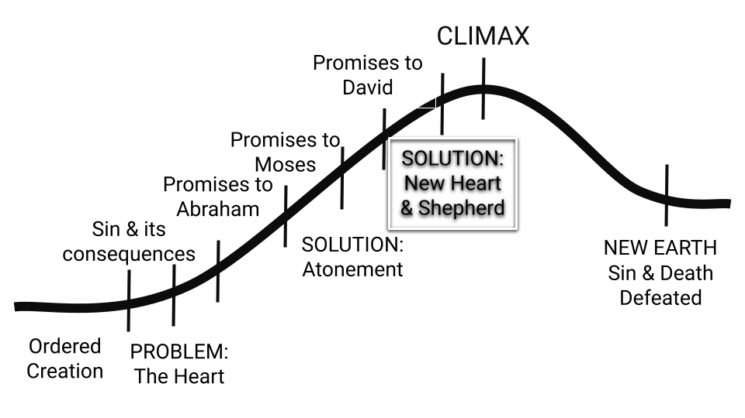

Figure 8.1: Plot arc - in the Gospels

Figure 8.2: Bible by Genre
The four gospels are written in the style of ancient biographies. The author of each gospel retells Jesus’ words and actions in order to demonstrate that he is the fulfillment of the Old Testament story and prophecy. In Jesus’ own words, he is the climax of the whole Bible, and all of it points to him (Luke 24:13-49).

The Solution of God: Our Response

As we come to our final lesson, we will spend time in our personal study exploring how Jesus fulfilled the Old Testament story. During the Large group teaching time, then, we will focus on our response to this story. In light of all that the LORD has done, how should we live?

Read the Bible passages below and answer the questions that follow.

1. The New Covenant

Luke 22:1-20

¹ Now the Festival of Unleavened Bread, called the Passover, was approaching, ² and the chief priests and the teachers of the law were looking for some way to get rid of Jesus, for they were afraid of the people. ³ Then Satan entered Judas, called Iscariot, one of the Twelve. ⁴ And Judas went to the chief priests and the officers of the temple guard and discussed with them how he might betray Jesus. ⁵ They were delighted and agreed to give him money. ⁶ He consented, and watched for an opportunity to hand Jesus over to them when no crowd was present.

⁷ Then came the day of Unleavened Bread on which the Passover lamb had to be sacrificed. ⁸ Jesus sent Peter and John, saying, “Go and make preparations for us to eat the Passover.” ⁹ “Where do you want us to prepare for it?” they asked. ¹⁰ He replied, “As you enter the city, a man carrying a jar of water will meet you. Follow him to the house that he enters, ¹¹ and say to the owner of the house, ‘The Teacher asks: Where is the guest room, where I may eat the Passover with my disciples?’ ¹² He will show you a large room upstairs, all furnished. Make preparations there.”

¹³ They left and found things just as Jesus had told them. So they prepared the Passover. ¹⁴ When the hour came, Jesus and his apostles reclined at the table. ¹⁵ And he said to them, “I have eagerly desired to eat this Passover with you before I suffer. ¹⁶ For I tell you, I will not eat it again until it finds fulfillment in the kingdom of God.”

¹⁷ After taking the cup, he gave thanks and said, “Take this and divide it among you. ¹⁸ For I tell you I will not drink again from the fruit of the vine until the kingdom of God comes.” ¹⁹ And he took bread, gave thanks and broke it, and gave it to them, saying, “This is my body given for you; do this in remembrance of me.” ²⁰ In the same way, after the supper he took the cup, saying, “This cup is the new covenant in my blood, which is poured out for you.

1. The New Covenant continued...
  - What festival is taking place in this text?

  - What was the Passover festival about? What did the Israelites remember each time they celebrated Passover? (If you’re not sure, refer to page 47 - The Story Between the Promises #2).

  - What does Luke say “had” to happen on the day when Jesus and his disciples celebrated the Passover.

  - What was the significance of Jesus eating bread and wine with his disciples? What was Jesus announcing as he handed them the bread and the wine?

    - What parallel does Luke seem to be drawing between Jesus and the Passover festival?

    - In Luke 22:20, Jesus announced that his death would usher in a new covenant. What did God promise through the prophets regarding this new covenant? (See Lesson #8 - page 86 if you need to refresh your memory!)

2. The Sacrifice

Read the following texts and note what Jesus said about the necessity and purpose of his own death.

Luke 9:21-22

²¹ Jesus strictly warned them not to tell this to anyone. ²² And he said, “The Son of Man must suffer many things and be rejected by the elders, the chief priests and the teachers of the law, and he must be killed and on the third day be raised to life.”

Luke 9:43b-45

⁴³ While everyone was marveling at all that Jesus did, he said to his disciples, ⁴⁴ “Listen carefully to what I am about to tell you: The Son of Man is going to be delivered into the hands of men.” ⁴⁵ But they did not understand what this meant. It was hidden from them, so that they did not grasp it, and they were afraid to ask him about it.

Luke 18:31-34

³¹ Jesus took the Twelve aside and told them, “We are going up to Jerusalem, and everything that is written by the prophets about the Son of Man will be fulfilled. ³² He will be delivered over to the Gentiles. They will mock him, insult him and spit on him; ³³ they will flog him and kill him. On the third day he will rise again.”

³⁴ The disciples did not understand any of this. Its meaning was hidden from them, and they did not know what he was talking about.
Luke 22:39-44

³⁹ Jesus went out as usual to the Mount of Olives, and his disciples followed him. ⁴⁰ On reaching the place, he said to them, “Pray that you will not fall into temptation.” ⁴¹ He withdrew about a stone’s throw beyond them, knelt down and prayed, ⁴² “Father, if you are willing, take this cup from me; yet not my will, but yours be done.” ⁴³ An angel from heaven appeared to him and strengthened him. ⁴⁴ And being in anguish, he prayed more earnestly, and his sweat was like drops of blood falling to the ground.

The Sacrifice continued...

  - In Luke 9 and Luke 18, what did Jesus say must happen to the “Son of Man” (a term which he uses to refer to himself).

  - Do his twelve disciples understand what he is talking about? Why not?

  - In light of the fact that he announced his own death three times in Luke 9 and 18, what do you notice about Jesus’ words in Luke 22?

    - What does this text teach you about the personal cost of his obedience in allowing himself to be crucified?

    - Rather than rushing ahead to finish the study, spend some time thinking about Jesus’ agony in Luke 22.
      - Think about what he felt like - knowing that he had to die, as the Passover lamb, to save those who would trust in him.

      - Praise Jesus for dying to secure your salvation.

3. Atonement

In the Old Testament, the people of God were made right with God through the annual Day of Atonement. Read the following texts to see how Jesus and other NT authors refer to the fact that Jesus’ death is the New Testament fulfillment of this event.

Luke 24:36-48

³⁶ After Jesus’s resurrection, “Jesus himself stood among [his disciples] and said to them, “Peace be with you.” ³⁷ They were startled and frightened, thinking they saw a ghost. ³⁸ He said to them, “Why are you troubled, and why do doubts rise in your minds? ³⁹ Look at my hands and my feet. It is I myself! Touch me and see; a ghost does not have flesh and bones, as you see I have.”

⁴⁰ When he had said this, he showed them his hands and feet. ⁴¹ And while they still did not believe it because of joy and amazement, he asked them, “Do you have anything here to eat?” ⁴² They gave him a piece of broiled fish, ⁴³ and he took it and ate it in their presence.

⁴⁴ He said to them, “This is what I told you while I was still with you: Everything must be fulfilled that is written about me in the Law of Moses, the Prophets and the Psalms.” ⁴⁵ Then he opened their minds so they could understand the Scriptures. ⁴⁶ He told them, “This is what is written: The Messiah will suffer and rise from the dead on the third day, ⁴⁷ and repentance for the forgiveness of sins will be preached in his name to all nations, beginning at Jerusalem. ⁴⁸ You are witnesses of these things.
Romans 3:25-26

²⁵ God presented Christ as a sacrifice of atonement, through the shedding of his blood—to be received by faith. He did this to demonstrate his righteousness, because in his forbearance he had left the sins committed beforehand unpunished— ²⁶ he did it to demonstrate his righteousness at the present time, so as to be just and the one who justifies those who have faith in Jesus.
Hebrews 9:11-15

¹¹ But when Christ came as high priest of the good things that are now already here, he went through the greater and more perfect tabernacle that is not made with human hands, that is to say, is not a part of this creation. ¹² He did not enter by means of the blood of goats and calves; but he entered the Most Holy Place once for all by his own blood, thus obtaining eternal redemption.

¹³ The blood of goats and bulls and the ashes of a heifer sprinkled on those who are ceremonially unclean sanctify them so that they are outwardly clean. ¹⁴ How much more, then, will the blood of Christ, who through the eternal Spirit offered himself unblemished to God, cleanse our consciences from acts that lead to death, so that we may serve the living God!

¹⁵ For this reason Christ is the mediator of a new covenant, that those who are called may receive the promised eternal inheritance—now that he has died as a ransom to set them free from the sins committed under the first covenant.

Atonement continued…
        - Read Luke 24:36-38 to answer this first set of questions.
          - What does Jesus affirm about “Moses, the Prophets and the Psalms” in this text?

          - What do you think he means when he talks about “Moses, the Prophets and the Psalms” as a group of texts? (refer to our bible genre diagrams if you need a hint)

          - We read earlier in Luke that the disciples didn't understand what Jesus was talking about. What happened now so that they understood?

          - What was written in “Moses and the Prophets and the Psalms” about the Messiah? What was his death to accomplish?

        - Read Romans 3:25-26 to answer the next questions.
          - What does Paul (the writer of Romans) say that God presented Jesus as?

          - How does someone become right with God (justified) according to Paul?

        - Read Hebrews 9:11-15 to answer the last questions.
          - How did Jesus secure eternal redemption for his people?

          - What is the effect of Jesus’ sacrifice on our behalf according to verse 14?

          - Refer back to the way that Ezekiel and Jeremiah spoke of the new covenant (see page 86-87). What imagery or language is the author of Hebrews using to draw connections between the promises of Ezekiel and Jeremiah and the work of Jesus?

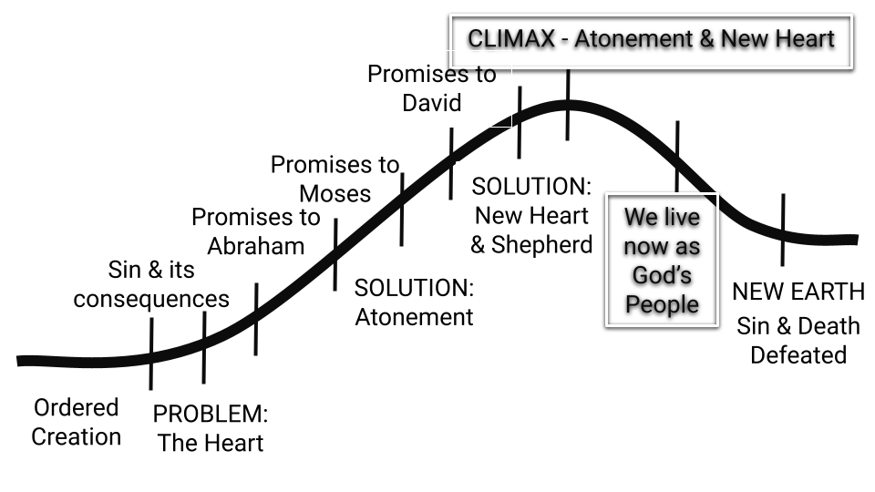

Figure 9.1: Plot arc - After the Gospels

REVIEW
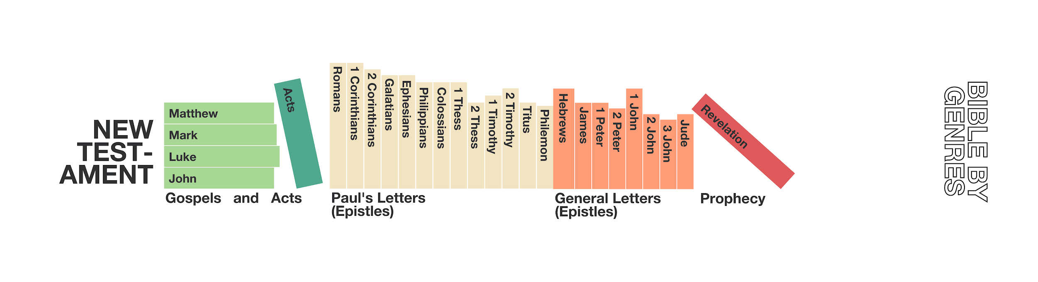
Figure 9.2: New Testament by Genre

The book of Acts was written by Luke, and is the history book of the New Testament. It tells the story of how the news of Jesus (the gospel) spread from Jerusalem, to Judea and Samaria and all the ends of the earth (Acts 1:8).

Acts is followed by a series of letters which were written to churches and individuals, teaching them what they should believe about Jesus and how they should live in light of his life, death and resurrection.

The New Testament ends with the book of Revelation, which affirms that Jesus will return to earth as both saviour and judge, and will recreate the heavens and earth (Revelation 21:1). This book urges God’s people to persevere, and invites those who have not yet trusted in Jesus to ...“Come!” Let the one who is thirsty come; and let the one who wishes take the free gift of the water of life” (Revelation 22:17).

Large Group Teaching

Lesson 9: The Solution of God - Our Response

Understand Your Position in Christ and Persevere in Faith - Hebrews 10

The Church is the New Temple and New Priesthood - 1 Peter 2:4-10

Walk in Step with the Spirit - Galatians 5:16-22

Hebrews 10 - Understand Your Position in Christ and Persevere in Faith

¹ The law is only a shadow of the good things that are coming—not the realities themselves. For this reason it can never, by the same sacrifices repeated endlessly year after year, make perfect those who draw near to worship. ² Otherwise, would they not have stopped being offered? For the worshipers would have been cleansed once for all, and would no longer have felt guilty for their sins. ³ But those sacrifices are an annual reminder of sins. ⁴ It is impossible for the blood of bulls and goats to take away sins….

¹¹ Day after day every priest stands and performs his religious duties; again and again he offers the same sacrifices, which can never take away sins. ¹² But when this priest had offered for all time one sacrifice for sins, he sat down at the right hand of God, ¹³ and since that time he waits for his enemies to be made his footstool. ¹⁴ For by one sacrifice he has made perfect forever those who are being made holy.

¹⁵ The Holy Spirit also testifies to us about this. First he says:

¹⁶ “This is the covenant I will make with them

after that time, says the Lord.

I will put my laws in their hearts,

and I will write them on their minds.”

¹⁷ Then he adds:

“Their sins and lawless acts

I will remember no more.”

¹⁸ And where these have been forgiven, sacrifice for sin is no longer necessary.

¹⁹ Therefore, brothers and sisters, since we have confidence to enter the Most Holy Place by the blood of Jesus, ²⁰ by a new and living way opened for us through the curtain, that is, his body, ²¹ and since we have a great priest over the house of God, ²² let us draw near to God with a sincere heart and with the full assurance that faith brings, having our hearts sprinkled to cleanse us from a guilty conscience and having our bodies washed with pure water. ²³ Let us hold unswervingly to the hope we profess, for he who promised is faithful. ²⁴ And let us consider how we may spur one another on toward love and good deeds, ²⁵ not giving up meeting together, as some are in the habit of doing, but encouraging one another—and all the more as you see the Day approaching.

²⁶ If we deliberately keep on sinning after we have received the knowledge of the truth, no sacrifice for sins is left, ²⁷ but only a fearful expectation of judgment and of raging fire that will consume the enemies of God.

²⁸ Anyone who rejected the law of Moses died without mercy on the testimony of two or three witnesses. ²⁹ How much more severely do you think someone deserves to be punished who has trampled the Son of God underfoot, who has treated as an unholy thing the blood of the covenant that sanctified them, and who has insulted the Spirit of grace? ³⁰ For we know him who said, “It is mine to avenge; I will repay,” and again, “The Lord will judge his people.”³¹ It is a dreadful thing to fall into the hands of the living God.

1 Peter 2:4-10 - The Church is the New Temple and New Priesthood

⁴ As you come to him, the living Stone—rejected by humans but chosen by God and precious to him— ⁵ you also, like living stones, are being built into a spiritual house to be a holy priesthood, offering spiritual sacrifices acceptable to God through Jesus Christ. ⁶ For in Scripture it says:

“See, I lay a stone in Zion,

a chosen and precious cornerstone,

and the one who trusts in him

will never be put to shame.”

⁷ Now to you who believe, this stone is precious. But to those who do not believe,

“The stone the builders rejected

has become the cornerstone,”

⁸ and, “A stone that causes people to stumble

and a rock that makes them fall.”

They stumble because they disobey the message—which is also what they were destined for.

⁹ But you are a chosen people, a royal priesthood, a holy nation, God’s special possession, that you may declare the praises of him who called you out of darkness into his wonderful light. ¹⁰ Once you were not a people, but now you are the people of God; once you had not received mercy, but now you have received mercy.

Galatians 5:16-22 - Walk in Step with the Spirit

¹⁶ So I say, walk by the Spirit, and you will not gratify the desires of the flesh. ¹⁷ For the flesh desires what is contrary to the Spirit, and the Spirit what is contrary to the flesh. They are in conflict with each other, so that you are not to do whatever you want. ¹⁸ But if you are led by the Spirit, you are not under the law. ¹⁹ The acts of the flesh are obvious: sexual immorality, impurity and debauchery; ²⁰ idolatry and witchcraft; hatred, discord, jealousy, fits of rage, selfish ambition, dissensions, factions ²¹ and envy; drunkenness, orgies, and the like. I warn you, as I did before, that those who live like this will not inherit the kingdom of God. ²² But the fruit of the Spirit is love, joy, peace, forbearance, kindness, goodness, faithfulness, ²³ gentleness and self-control. Against such things there is no law. ²⁴ Those who belong to Christ Jesus have crucified the flesh with its passions and desires. ²⁵ Since we live by the Spirit, let us keep in step with the Spirit.

Appendix #1 - Relation Between Old & New Testaments:

- God’s nature does not change.
  - His character and priorities are consistent throughout scripture. The “God of the Old Testament” is the same as the “God of the New”
  - Father, Son, Holy Spirit - coexistent, coequal, coeternal,
  - Hebrews 13:8

- God’s plan does not change (Ephesians 1:3-10)
  - but it was revealed to people in progressive stages. Covenant promises build on each other until they are fulfilled in the work and person of Jesus.

- The nature of salvation does not change.
  - In both the Old and New Testaments people are saved by God’s grace, through faith, not by works (Exodus, Galatians, Hebrews).
  - But, in both the Old and New Testaments “true faith” is authenticated by works. Our lives must be in alignment with our profession, or our profession of faith is false.

- God’s Moral Law does not change.
  - The 10 Commandments, and other laws which communicate ethics do not change. (eg. Love the Lord Your God with all your heart, mind, soul and strength and love your neighbour as yourself).
  - Jesus teaches God’s moral law and emphasizes that this isn’t an outward show. Hearts must be right before God.
    - NT Sermon on the Mount (Matthew 5-7)
    - 1 Peter 1:15 - You shall be holy for I am holy
  - Moral laws define sin

- God’s Ceremonial Law / Levitical Law is fulfilled in the New Testament
  - OT Laws which highlight our need for purification, cleansing and atonement are fulfilled in the work and person of Jesus.
  - “[In the old covenant] ... gifts and sacrifices are offered that cannot perfect the conscience of the worshiper, but deal only with food and drink and various washings, regulations for the body imposed until the time of reformation.” (Heb 9:9-10)

  - “Israel was to observe various ceremonial laws - for example those pertaining to clean and unclean food. To be ceremonially clean was symbolic of being morally holy. This explains why the text on clean and unclean food is bracketed by references to Israel being “a people holy to the LORD” (vv 2,21).
  - In the new covenant the requirement to observe these ceremonial laws has been abrogated (repealed, revoked, rescinded), because they have served their purpose of pointing to the perfect holiness of Christ (Col 2:16-23, Heb 9:1 - 10:26)” Source: Gospel Transformation Bible Footnotes - Deuteronomy 14:1-21

  - The requirements of God’s moral and ceremonial Law is fulfilled in the work and person of Jesus.
    - Jesus lived a life of perfect obedience to God’s moral law
    - Jesus died as the perfect sacrifice
    - Jesus is now our prophet, our priest and our king

  - “And he took bread, and when he had given thanks, he broke it and gave it to them, saying, “This is my body, which is given for you. Do this in remembrance of me.” And likewise the cup after they had eaten, saying, “This cup that is poured out for you is the new covenant in my blood.” Luke 22:19-20

Ezekiel 36, Jeremiah 31

- The “mediator” changes under the new covenant.
  - In the OT, Moses “mediated” between God and the people (Deut 9:25-29). Through the Mosaic Law, God showed them how to live. The law stood between God and the people. To please God, one had to follow the law.
  - In the NT, Jesus “mediates” between God and us (Hebrews 9:15, 12:24). Jesus has fulfilled the requirements of the ceremonial law. Jesus now stands between God and us. To please God, we have to follow Jesus: relying on the sufficiency of His sacrifice for our salvation, and by living in obedience to His teaching - the Law of Christ (Gal 6:2), (1 John 2:3-6).

Appendix #2 - Reading the Bible with Jesus at the Center.
One of the central themes of this Christian Story curriculum is that Jesus is the center of the biblical story (as he states himself in Luke 24), and that the Old Testament stories, laws, poetry and prophecy point towards him. As we read any section of parts of the Bible, then, it is appropriate for us to follow a pathway as we think through what we are reading:
#1 Understand Their Story: What did this biblical text mean to its original audience (the Israelites in the Old Testament, the early church in the New Testament)?
#2 Connect to His Story: What information does this biblical text provide about Jesus?
#3 Apply to Our Story: How does this text now apply to us, 2000+ years later in a different part of
the world?
This process can be demonstrated through the following diagram:
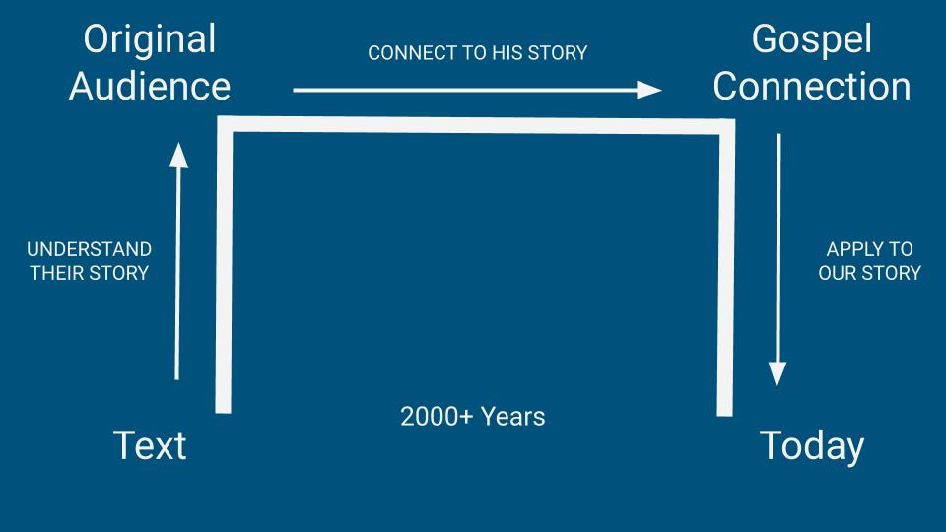

So, how can we get to “the point” of Jesus by following the Pathway?

- Understand Their Story
- After you have read the story or section of scripture a few times, ask yourself: How does the biblical text that you are studying relate to the gospel: Jesus’ life, death, resurrection, and the forgiveness of sins and call to repentance that is required in response?

  - Each Biblical Text can fit into one of the following categories:

    - Preparatory - it prepares people for the coming of Jesus by showing them the nature of sin and people’s need for a savior (most Old Testament Texts).

    - Predictive - it directly predicts something about the future Messiah / Savior (eg Psalm 2, Isaiah 53, the OT sacrificial system, the Tabernacle construction)

    - Reflective - it reflects on the ministry of Jesus by illuminating who he is and what he calls us to do (most of the gospels, and parts of NT Letters which describe Jesus and his ministry - eg Phil 2:5-11)

    - Resultant - it teaches how we should live as a result of receiving God’s grace through salvation (in OT), or as a result of receiving God’s grace through belief in Jesus’ life, death and resurrection.

- Once you have figured out what category the text fits into, then connect it to Jesus’ story by asking some questions!

- Preparatory Texts
  - What do we learn about how Christ is foreshadowed/anticipated?
  - What do we learn about who God is?
  - What do we learn about the relationship between God and man?
  - What do we learn about the problem of sin?
  - What does it look like to follow God in this text?
  - How does God save in this text?

- Predictive Texts
  - How is the Gospel and our need for Christ foreshadowed?

- Reflective Texts
  - What do we learn about who Jesus is ?
  - What does Jesus say he has come to do?
  - How does Jesus help people to see their need of him?
  - What appears to be keeping or have kept people from responding to Jesus?
  - What response is Jesus calling from those he meets?

- Resultant Texts
  - What do we learn about who God is?
  - What do we learn about the relationship between God and man?
  - What do we learn about the problem of sin and how Jesus has dealt with it?
  - What does it look like to be a disciple? How are we empowered to be a disciple?
  - What does this text teach me about who I am in Christ or what Jesus has done for me, in order to empower or convince me to obey?
  - How is our need for Jesus seen here?

For more teaching on Connecting to the Gospel topic, you can access a video here.

JI Packer, Knowing God, p 83.
Note: When biblical authors talk about the Bible they don’t use the word “Bible”, but instead refer to it as “Scripture” or, regarding the Old Testament, as “the law of God”.
Atonement means: compensation for a wrong, or the act of atoning for (compensating for) sin or wrongdoing (especially appeasing a deity) - vocabulary.com
Aaron was chosen by God to be Israel’s High Priest (Exodus 28).
Figure 7.1 Taken from St. Helen’s Bible Overview course
In Daniel 7:9-14, we read that the “Son of Man” is the one to whom the LORD gives authority, glory, power and an everlasting kingdom. By referring to himself as the “Son of Man”, Jesus is affirming that he is the fulfillment of Daniel’s prophecy.
Justify means: “to judge, regard, or treat as righteous and worthy of salvation” (merriam-webster.com)
Gospel means: good news!
The three steps outlined in this paragraph are adaptations of material found in The Charles Simeon Trust’s “Pathway to Preparation” teaching materials at https://simeontrust.org/courses/first-principles/
Bryan Chapell, Christ-Centered Preaching: Redeeming the Expository Sermon, 2nd ed. (Grand Rapids, MI: Baker Academic, 2005), 282-288.

